by
Cathy Catherine Hlungwani
Research assignment presented in partial fulfilment for the requirements for the degree of MEng (Structured) (Industrial Engineering) in the Faculty of Engineering at Stellenbosch University
Supervisor: Prof. Evan Gilbert
December 2026

Declaration
By submitting this research assignment electronically, I declare that the entirety of the work contained therein is my own, original work, that I am the sole author thereof (save to the extent explicitly otherwise stated), that reproduction and publication thereof by Stellenbosch University will not infringe any third party rights and that I have not previously in its entirety or in part submitted it for obtaining any qualification.
During the preparation of this research assignment, the author used artificial Intelligent-assisted tool(s) to identify relevant literature, generate code, generate images, improve the readability and language of the thesis. After using the artificial intelligence-assisted tool(s), the author reviewed and edited the content and takes full responsibility for the content of the work.
Date: March 2026

Copyright © 2026 Stellenbosch University
All rights reserved
Abstract
This study investigates whether machine learning (ML) techniques can enhance the timing of equity style factors in the South African market, focusing on the relative performance of momentum, value and quality factors. While factor timing is well explored in developed markets, evidence for emerging markets remains limited despite their higher volatility, structural inefficiencies and state-dependent return dynamics. To address this gap, the study evaluates a hierarchy of ML models—logistic regression, generalised additive models (GAMs) and extreme gradient boosting (XGBoost)—to assess whether increasing model flexibility yields incremental predictive value.
Models are trained using purged combinatorial cross-validation to mitigate temporal leakage and evaluated using a rolling walk-forward framework that mirrors real-world deployment. Results show a consistent improvement in predictive performance as model complexity increases: XGBoost outperforms both GAM and logistic regression across key metrics such as accuracy, recall, F1 score and ROC AUC, particularly for the momentum-versus-value pair. GAM offers intermediate gains, while logistic regression performs weakest, reflecting the limitations of linear specification.
Predictability differs across factor pairs, with momentum–value exhibiting the strongest structure and value–quality the weakest. Although XGBoost achieves the highest directional accuracy, its elevated log-loss indicates imperfect probability calibration. Overall, the findings show that nonlinear ML models can extract economically meaningful signals from South African factor dynamics, supporting their potential role in dynamic factor allocation and motivating future work on portfolio implementation and regime-based extensions.

Acknowledgements
xxxx

Contents
- Introduction 8
1.1 Background 9
1.2 Problem statement 11
1.3 Scope and objectives 11
1.4 Research methodology 12
1.5 Contribution to data science 12
1.6 Research assignment outline 13
- Literature Review 15
2.1 Foundational framework on factor timing 15
2.2 Machine Learning in Finance 18
2.3 Application of ML in factor timing strategies 23
2.4 ML Factor timing strategies – South African equity markets 27
2.5 Conclusion 27
- Methodology 29
3.1 Research design and empirical framework 29
3.2 Factor definitions 30
3.3 Data sources and pre-processing 31
3.4 Data labelling 32
3.5 Feature selection 35
3.6 Model training 38
3.7 Hyperparameter tuning - Combinatorial Cross-Purged Validation 44
3.8 Walk forward Cross-Validation 45
3.9 Performance evaluation 45
3.10 Conclusion 47
- Results 48
4.1 Factor behaviour 48
4.2 Out-of-Sample predictive power 51
4.1 Easiest and hardest factor pairs 55
4.2 Feature Importance 58
4.3 Validation methodology impact 58
4.4 Temporal Stability and Regime Dependence 58
- References 60

List of Figures
Figure 1: Trend-scanning results each factor pairs 33
Figure 2: Hierarchical agglomeration clustering applied to the features space 35
Figure 3: Illustrative ROC curve showing the trade-off between TPR and FPR across varying classification thresholds. 46
Figure 4: Cumulative factor returns 47
Figure 5: 24-month rolling factor returns 48

List of Tables
Table 1 30
Table 2: Classification of representative features with associated economic rationale and supporting empirical evidence 35
Table 3 Model comparison 42
Table 4 43
Table 5: Out-of-sample average accuracy of the three models across the three factor pairings. 51
Table 6: Out-of-sample log-loss 51
Table 7: 52
Table 8: 53
Table 9: 54
Table 10: 55
Table 10: Logistic 58
Table 11: GAM 59
Table 12: XGBoost 60

Introduction
Traditional asset pricing models have identified a few company characteristics, known as factors, that drive the cross-section of equity returns (Fama & French, 1992; Fama & French, 1993; Harvey, et al., 2016). Factors such as momentum, value, size, quality, profitability, and low volatility are widely documented sources of long-term return (Carhart, 1997; Asness, et al., 2013; Asness, et al., 2019; Piotroski, 2000). However, short-term performance is highly cyclical, creating opportunities for factor timing strategies that seek to dynamically allocate capital across factors based on expected future performance (Arnott, et al., 2023; Blitz, et al., 2014).
Traditional econometric approaches provide valuable insights into long-term factor premia, but their reliance on linearity assumptions limits their ability to capture nonlinear interactions and complex market dynamics that underpin short-run factor rotations (Cont, 2001; Campbell, et al., 1997). In contrast, Machine Learning (‘ML’ hereafter) methodologies can account for these complexities and offer complementary perspectives to conventional approaches (Gu, et al., 2020; Giglio, et al., 2022; Wang, 2023; Moritz & Zimmermann, 2016).
While ML-based factor timing has been explored in developed equity markets, its application in emerging markets remains limited. The potential benefits of ML—capturing complex, non-linear dynamics—may be even more pronounced in emerging markets, which are often characterized by greater informational inefficiencies, higher idiosyncratic risk, and unique market microstructures (Cakici, et al., 2023; Leung, et al., 2021). Consequently, the South African equity market provides a compelling case for testing ML model robustness.
The study investigates the application of ML models for timing style factors—specifically momentum, value, and quality—within the South African equity market. The objective is to model the factors’ relative performance to assess whether nonlinear interactions in factor dynamics are a potential source of predictive gain (Gu, et al., 2020). To demonstrate the incremental benefits of flexibility in model specification, we assess three model classes. Firstly, a logistic regression model which is grounded in economic intuition and statistical interpretability. The linear log-odds structure provides clear marginal effects of each predictor on relative factor performance. Generalised Additive Models (GAM) relax the linearity assumption by introducing smooth nonlinear transformations of individual predictors. These models retain additive transparency by allowing inspection of how each variable influences the probability of outperformance while capturing curvature that linear models fail to identify. Building on prior evidence that shows that tree-based models outperform simpler approaches within the South African markets (Page, et al., 2024), we use Extreme Gradient Boosting (XGBoost) trees which represents a fully non-parametric approach, capable of modelling complex interactions and high-order nonlinearities that may arise from interdependencies between market, economic, and sentiment features. These models exploit residual information missed by simpler models, often yielding the strongest predictive performance at the cost of interpretability.
Together, these models provide a hierarchy of complexity: from interpretable linear relationships to flexible smooth effects and, finally, to data-driven nonparametric inference. This layered design allows for a structured evaluation of whether increasing model complexity yields meaningful economic value in predicting relative factor.
The remainder of this chapter continues with a background sketch, the research problem and an introduction to the research design. This is followed by an overview of the research methodology. Lastly, reference is made to the contribution of the research results and an orientation towards the rest of the study concludes this chapter.

Background
The literature establishes a clear trajectory from the identification of persistent factor premia to the complex challenge of dynamically harvesting them. While foundational models like the Capital Asset Pricing Model (CAPM) provided a starting point (Lintner, 1965; Sharpe, 1964), the subsequent expansion to multi-factor models confirmed that equity returns are driven by multiple, academically validated sources of risk and return, such as value, momentum, and quality (Fama & French, 1992; Fama & French, 2015.; Carhart, 1997). The economic origin of these premia remains debated, straddling rational risk-based (Fama & French, 1993; Fama & French, 2015.) and behavioural bias-based explanations (Lakonishok, et al., 1994; Daniel, et al., 1998), suggesting that their drivers are multifaceted and not attributable to a single, unified theory (Asness, et al., 2000; Gupta & Kelly, 2019).
Empirically, these factors are not static rewards but exhibit significant cyclicality and regime-dependent behaviour, leading to prolonged periods of outperformance and deep drawdowns that challenge static, buy-and-hold factor investing (Ilmanen & Kizer, 2012; Daniel & Moskowitz, 2016; Bessler, 2021). This volatility underpins the appeal of factor timing as a strategy to enhance returns and, more critically, to manage risk (Arnott, et al., 2016). Evidence demonstrates that even simple dynamic rules based on signals like valuation and momentum can yield substantial improvements in risk-adjusted returns (Asness, et al., 2000; Gupta & Kelly, 2019; Huang, et al., 2020).
Literature also highlights the structural difficulty of predicting factor premia cycles. Their determinants appear nonlinear, high-dimensional, and sensitive to shifting macro-financial conditions (Cotturo, et al., 2024; Gu, et al., 2020; Leung, et al., 2021). Traditional linear models are ill-suited to capturing such interactions, especially when predictor spaces are large relative to available historical samples (Feng, et al., 2020). Moreover, factor behaviour evolves across time in ways that favour more flexible and adaptive modelling techniques (Ilmanen, et al., 2021; Huang, et al., 2020). These structural limitations have created a compelling case for the application of ML techniques (Gu, et al., 2020; Leung, et al., 2021). ML's ability to approximate complex functional forms without pre-specification, handle high-dimensional data, and adapt to evolving market regimes (Ilmanen, et al., 2021; Feng, et al., 2020) positions it as a promising framework for advancing the practice of factor timing. Therefore, the literature logically culminates in the proposition that ML methods are a natural and potent tool for navigating the intricate, high-dimensional, and nonlinear landscape of factor return prediction (Cotturo, et al., 2024).

Problem statement
This study addresses whether machine learning models can extract robust and economically meaningful predictive signals from South African factor dynamics to improve the tactical timing of relative factor performance. While ML techniques show strong predictive capacity in developed markets, their applicability to emerging markets—characterised by higher volatility, structural inefficiencies, and shorter datasets—remains largely unexplored.

Scope and objectives
This study is scoped to the analysis of momentum, value and quality style factors within the South African equity market, focusing specifically on forecasting the relative performance between each pair of factors—a formulation consistent with recent applications of ML to directional financial prediction (Piovezan & de Andrea Jr., 2022; Cotturo et al., 2024). The empirical design draws on a broad data universe comprising historical market information, macroeconomic indicators, and factor-specific time-series inputs, reflecting evidence that both price-based and macro-state variables can influence factor premia (Gu et al., 2020; Fang et al., 2022). While the present investigation concentrates on statistical model evaluation, practical considerations such as portfolio back-testing, transaction-cost, and implementation risk are intentionally left for future research.
Within this scope, the study has three primary objectives: first, to compare the predictive performance of linear, semi-parametric and nonlinear model classes—specifically logistic regression, GAMs and XGBoost—for timing factor outperformance; second, to determine whether greater model flexibility translates into improved predictive accuracy; and lastly, to evaluate the robustness of the resulting predictive signals using purged combinatorial cross-validation and rolling walk-forward evaluation, both widely regarded as appropriate techniques for mitigating look-ahead bias and non-stationarity in financial time-series modelling (Lopez de Prado, 2018; 2020).

Research methodology
Our methodological framework follows a supervised learning pipeline adapted to financial time series. First, raw data undergoes preprocessing to address look-ahead bias and missing values. Trend-scanning is then applied to construct binary labels that capture the relative outperformance of factors. The dataset is enriched with a comprehensive feature set representing market, macroeconomic, sentiment, and valuation dimensions. Logistic regression, Generalized Additive Models (GAM), and Extreme Gradient Boosting (XGBoost) are then trained under a unified validation framework that combines Combinatorial Purged Cross-Validation (CPCV) for hyperparameter tuning and walk-forward validation for performance evaluation. Model performance is assessed using ROC-AUC and PR-AUC to evaluate predictive power under class imbalance conditions. To assess economic performance, we use Sharpe ratios and maximum drawdown risk-adjusted metrics.

Contribution to data science
The contribution of this study to the fields of data science and factor timing strategies is threefold:
Firstly, comparative modelling contribution: It provides the first systematic, comparative evaluation of linear, semi-parametric, and nonlinear machine learning models for factor timing within the South African equity market, addressing a notable gap in the emerging-market literature.
Secondly, methodological contribution: It empirically demonstrates the extent to which enhanced model flexibility improves predictive performance in a volatile and informationally inefficient market setting, offering insights into the suitability of different algorithm classes for such environments.
Lastly, validation framework contribution: It implements and advocates for a rigorous two-stage validation framework—integrating purged combinatorial cross-validation with rolling walk-forward testing—to ensure robust performance estimation and mitigate overfitting in the presence of serial correlation and time-varying data structures.
Collectively, these contributions extend both the local and international discourse on the application of machine learning to dynamic factor allocation, providing a methodological and empirical benchmark for future research in similar markets.

Research assignment outline
The orientation of the study is as follows:
Chapter 1 - Introduction of the study: This chapter outline the background to the study. It formulates the research problem, objectives, and provides the research methods employed in this study.
Chapter 2 – Literature Review: We reviews the literature on factor premia, factor timing, and ML applications in factor timing, highlighting empirical findings and research gaps.
Chapter 3 – Methodology: This chapter details the data, feature selection, modelling approaches, and validation procedures used in the study.
Chapter 4 – Research Results: Presents the empirical results, including model comparison, performance analysis, and robustness checks.
Chapter 5 – Conclusions and Recommendations: We discusses the implications of the findings, outlines the study’s limitations, and proposes directions for future research.

Literature Review

Foundational framework on factor timing
The foundation of equity factor research lies in the Capital Asset Pricing Model (CAPM), developed by (Lintner, 1965) and (Sharpe, 1964) which attributes equity returns solely to market risk, positing that investors earn a premium for bearing undiversifiable risk. Subsequently, empirical anomalies demonstrated that while influential, single-factor models could not adequately explain persistence patterns in returns. While (Fama & French, 1992) acknowledges market risk as a driver of returns, they introduced size and value premia to augment the market risk factor. They demonstrated that smaller firms (size factor) and stocks with high book-to-market ratios (value stocks) earn higher returns, unexplained by the CAPM model. Following the findings of (Jegadeesh & Titman, 1993) who showed that stocks with strong recent performance tend to continue outperforming, (Carhart, 1997) incorporated the momentum factor to the Fama-French 3-factor model. Fama & French would later extend the 3-factor model to include profitability and investment factors, reflecting corporate fundamentals linked to long-horizon expected returns (Fama & French, 2015). Over the last decade, asset pricing research continued to uncover a rapidly expanding set of cross-sectional return predictors. This proliferation of factors (i.e. the factor zoo), is partially attributed to insufficiently stringent statistical controls in academic testing, with many factors lacking economic justification and fail to replicate in out-of-sample testing (Feng, et al., 2020). Nevertheless, a core set of factors—value, size, momentum, profitability, low-risk, and investment—are widely regarded as academically validated (Harvey, et al., 2016) and economically interpretable (Fama & French, 2015; Jegadeesh & Titman, 1993; Blitz, 2007). This study focuses on three of these academically validated factors: value, momentum, and quality.
Although the empirical existence of factor premia is well established, their economic origin remains contested. The persistence of factor returns has been explained through two competing, yet mutually exclusive theories. On the one hand, rational finance perspective posits that premia compensate investors for bearing fundamental, non-diversifiable macroeconomic risks (Fama & French, 1993; Fama & French, 2015). On the other hand, behavioural finance perspective attributes these premia to systematic investor biases—such as overreaction or extrapolation—that cause behavioural premia to persist (Lakonishok, et al., 1994; Daniel, et al., 1998). The critical mechanism allowing these behavioural anomalies to persist stem from limitations to arbitrage, where real-world constraints prevent the efficient elimination of mispricing (Shleifer & Vishny, 1997). If these two empirically supported explanations exists, factor premia are unlikely to have a single unified origin. While some premia may be largely compensatory for macroeconomic risks (Fama & French, 2015), others may be more strongly influenced by persistent behavioural biases (Daniel, et al., 1998). Therefore, it is plausible that factor returns are driven by complex and multi-faceted variables that extend beyond economic fundamentals (Asness, et al., 2000; Gupta & Kelly, 2019; Huang, et al., 2020).
Although the theoretical underpinnings of factor premia remain contested, their documented persistence in empirical research has spurred significant interest in constructing portfolios to harvest these risk premia. A naïve diversification strategy where capital is allocated equally across factors could potentially harvest long-term premia (DeMiguel, et al., 2009). However, factor returns tend to be highly cyclical, exhibiting prolonged periods of outperformance and underperformance, often lasting several years and not straightforwardly attributable to macro-economic cycles (Ilmanen & Kizer, 2012; Bessler, 2021; Daniel & Moskowitz, 2016). The recurrence of value crashes and growth rallies in empirical history suggests that even a diversified factor portfolio can endure multi-year underperformance depending on regime shift (Asness, et al., 2000; Arnott, et al., 2016). While factors are regime dependant and predisposed to multi-year drawdowns, their cycles are typically asynchronous, suggesting that dynamic reallocation across factors could improve risk-return outcomes relative to static diversification (Ilmanen & Kizer, 2012).
This insight underpins the concept of factor timing. By dynamically overweighting factors expected to outperform in the near future while underweighting those facing headwinds, an investor can potentially enhance returns and, crucially, mitigate the deep, regime-dependent drawdowns that plague static portfolios (Arnott, et al., 2016).
Empirical evidence shows that even relatively simple linear timing rules can deliver economically meaningful improvements to static allocations. Earlier work by (Asness, et al., 2000) and 2007 established a simple valuation-based signal for timing the value factor, yielding substantially higher returns. (Gupta & Kelly, 2019) systematically quantified the performance gains from timing a broad set of factors. Their key result was that a timing strategy based on factor momentum and valuation measures generated substantial alpha and superior Sharpe ratios compared to a static factor portfolio. They showed that these predictors were not just statistically significant but delivered economically meaningful forecasting ability, directly translating into enhanced risk-adjusted returns. Similarly, (Huang, et al., 2020) showed that that applying a dynamic weighting scheme to time-series momentum could significantly improve the strategy's Sharpe ratio and reduce its severe drawdowns. Collectively, these findings suggest that factor timing may enhance long-term returns and serve as an effective risk-management tool.
However, timing factor premia is inherently challenging. As synthesized by (Cotturo, et al., 2024) these challenges are fourfold; Firstly, the fundamental drivers of factor returns are not fully understood and likely comprise a complex set of financial and macro-economic variables. Secondly, the uncertainty surrounding the underlying functional relationship between factor premia and their determinants. This relationship is likely to be highly nonlinear and shaped by complex interactions among multiple predictors (Gu, et al., 2020; Leung, et al., 2021). Thirdly, factors are inherently dynamic with their performance contingent on a complex interplay between long- and short-term macroeconomic and financial conditions (Ilmanen, et al., 2021). These challenges motivate for approaches capable of capturing nonlinear interactions, adapting to evolving market states, and exploiting high-dimensional information. Finally,
The structural challenges inherent in timing factor premia have led recent research to explore the use of Machine Learning (ML) methods. ML approaches do not require the pre-specification of a functional form, allowing them to approximate complex, nonlinear relationships between predictors and asset returns (Gu, et al., 2020). A growing body of evidence shows that factor returns are influenced by interaction effects and nonlinear dynamics that linear models struggle to capture (Leung, et al., 2021; Bryzgalova, et al., 2023). ML methods are also designed to operate effectively in high-dimensional environments, where the number of potential predictors may be large relative to the sample size (Feng et al., 2018; Rapach & Zhou, 2013). Furthermore, several studies find that market conditions and factor behaviour evolve over time in ways that favour more flexible, adaptive modelling frameworks (Huang, et al., 2020; Ilmanen, et al., 2021). Considering these empirical findings, ML techniques have emerged as a natural candidate for modelling the nonlinear, high-dimensional and regime-dependent features that characterise factor timing problems (Cotturo, et al., 2024).

Machine Learning in Finance
ML emerged at the intersection of computer science, data science and artificial intelligence (‘AI’ hereafter) as a framework for constructing data-driven models that improve predictive performance through exposure to data rather than explicit rule-based programming (Mitchell, 1997; Bishop, 2006). In contrast to traditional econometric approaches that rely on pre-specified functional forms, ML methods emphasise flexible function approximation, statistical learning theory, and generalisation to unseen data (Bishop, 2006; James, et al., 2021). These properties have motivated their growing adoption in financial economics, where return-generating processes are widely documented to be noisy, nonlinear, and regime-dependent. ML literature commonly categorises learning paradigms according to the nature of the available information and the learning objective (Bishop, 2006; Hastie, et al., 2009; Sutton & Barto, 2018):
- Supervised learning refers to a family of predictive modelling techniques in which algorithms learn a mapping from input variables (predictors) to an output variable (label) using historical data. Formally grounded in statistical learning theory, supervised learning is framed as a risk minimisation problem in which model parameters are estimated by minimising an expected loss function, often subject to regularisation to control model complexity and improve generalisation (Hastie & Friedman, 2009; Vapnik, 1999). As input data is fed into the machine learning algorithm, it adjusts its parameters until the model has been fitted appropriately (James, et al., 2021).
- Unsupervised learning, by contrast, involves algorithms that learn patterns and structures from input data without any labelled outcomes or supervision (Jain, et al., 1999; Bishop, 2006). Rather than predicting a response variable, these methods aim to model the underlying distribution, geometry, or dependency structure of the input space. The goal is to model the underlying structure or distribution in the data to learn more about it, often through clustering or dimensionality reduction.
- Reinforcement learning represents a distinct goal-oriented learning paradigm where an autonomous agent learns to make decisions by performing actions in an environment to maximize a cumulative reward signal (Sutton & Barto, 2018). Through a process of trial-and-error, the agent discovers which actions yield the greatest rewards, learning an optimal policy for achieving its long-term goal. Reinforcement learning is particularly suited to control and sequential decision problems but is typically more complex and data-intensive than supervised or unsupervised approaches.
Within supervised learning, literature distinguishes between model families according to their functional flexibility, interpretability, and capacity to capture nonlinear interactions. Regularised linear models, semi-parametric methods, tree-based ensembles, and deep learning architectures occupy distinct positions along this spectrum, reflecting trade-offs between transparency, robustness, and expressive power (Bishop, 2006; Gu, et al., 2020). This body of work provides the conceptual foundation for the model families considered in this study.

Regularised & Semi-Parametric models
A central concern in empirical return prediction is the instability of parameter estimates in the presence of high-dimensional and strongly correlated predictors, a feature that is particularly pronounced in macro-financial datasets (Hastie & Friedman, 2009). The statistical learning literature addresses this challenge through regularisation, which constrains model complexity by penalising large coefficient estimates, thereby reducing variance and improving out-of-sample generalisation (Vapnik, 1999).
Early contributions such as ridge regression introduced an ℓ₂ penalty to stabilise linear models under multicollinearity by shrinking coefficients toward zero without eliminating predictors (Hoerl & Kennard, 1970). (Tibshirina, 1996) extended this framework through the LASSO, which applies an ℓ₁ penalty that induces sparsity by setting some coefficients exactly to zero, facilitating variable selection and interpretability. Subsequent research highlighted limitations of pure ℓ₁ regularisation in environments with highly correlated predictors, motivating the elastic net, which combines ℓ₁ and ℓ₂ penalties to balance sparsity and stability (Zou & Hastie, 2005).
While regularisation addresses estimation instability, linear models remain limited by their global linear functional form. This limitation motivated the development of semi-parametric models, most notably Generalised Additive Models (GAMs), which extend linear predictors by replacing fixed coefficients with smooth, data-driven functions of individual covariates (Hastie & Tibshirani, 1986). By allowing nonlinear marginal effects while preserving additivity, GAMs capture economically intuitive relationships without resorting to fully nonparametric complexity. Penalised regression splines are used to control smoothness and prevent overfitting, positioning GAMs as an intermediate class between linear and fully nonlinear models (Wood, 2017). As such, GAMs provide an interpretable yet flexible framework for modelling gradual, regime-dependent dynamics in financial time series.

Tree-Based Models
Within supervised learning, tree-based models represent a further departure from parametric and semi-parametric specifications by learning nonlinear decision rules through recursive partitioning of the predictor space (Hastie, et al., 2009). The aim is to create partitions that are as pure as possible with respect to the target variable, typically evaluated using measures such as Gini impurity or entropy. These models construct interactions and threshold effects endogenously from the data, allowing for locally adaptive relationships between predictors and outcomes. This flexibility makes tree-based methods particularly well suited to capturing regime shifts and higher-order interactions that are difficult to model using linear or additive frameworks[Ref].
Early studies documented that single decision trees suffer from high variance and limited out-of-sample robustness, often fitting noise rather than persistent structure (Breiman, et al., 1984). To address these shortcomings, the literature developed ensemble methods that aggregate information across multiple trees. Random Forests employ bootstrap aggregation and random feature selection to decorrelate individual trees, yielding more stable and robust predictions (Breiman, 2001). Gradient boosting methods construct trees sequentially, with each iteration focusing on correcting the errors of the existing ensemble through gradient-based optimisation of a loss function (Friedman, 2001). Subsequent innovations such as XGBoost and LightGBM introduced regularisation, shrinkage, and computational optimisations that significantly improved performance and scalability, leading to their widespread adoption in empirical finance and asset pricing research (Chen & Guestrin, 2016)(Chen & Guestrin, 2016; Ke et al., 2017).
Within the factor timing literature, tree-based ensemble methods are frequently characterised by their strong predictive performance and ability to model complex nonlinear interactions, albeit at the cost of reduced interpretability and increased sensitivity to model tuning relative to linear and semi-parametric approaches (Gu, Kelly & Xiu, 2020).

Deep learning and hybrid models
As supervised learning research progressed, limitations in both additive semi-parametric models and tree-based ensembles motivated the development of deep learning architectures capable of representing highly complex, nonlinear, and dynamic relationships in high-dimensional data (Goodfellow, Bengio & Courville, 2016). Unlike earlier model classes, deep neural networks employ multiple layers of nonlinear transformations that allow features to be learned hierarchically from the data, rather than being manually specified or implicitly constructed through tree splits. This expressive capacity has driven their increasing adoption in empirical finance, particularly in settings characterised by weak signals, evolving regimes, and complex interaction structures (Gu, Kelly & Xiu, 2020).
Feedforward neural networks (FNNs) constitute the foundational deep learning architecture and represent a direct extension of nonlinear function approximation within supervised learning (Goodfellow et al., 2016). In the literature, FNNs are typically viewed as universal approximators capable of modelling arbitrarily complex relationships between predictors and outcomes, provided sufficient depth and capacity (Hornik, Stinchcombe & White, 1989). This property has made them attractive for capturing nonlinear cross-factor interactions and higher-order dependencies in financial prediction tasks. However, because FNNs treat observations as conditionally independent, they do not explicitly model temporal dependence, and their effectiveness in time-series applications often hinges on the quality of engineered lagged inputs or summary features (Goodfellow et al., 2016).
To address the inability of feedforward architectures to model temporal dependence directly, the literature introduced recurrent neural networks (RNNs), which incorporate feedback connections that allow information to persist across time steps (Rumelhart, Hinton & Williams, 1986). This architectural feature enables RNNs to model sequential dependence and dynamic evolution, making them conceptually well suited to financial time series and factor premia that exhibit persistence, reversals, and regime shifts. Early empirical studies, however, documented practical limitations of standard RNNs arising from vanishing and exploding gradient problems, which impede learning of long-horizon dependencies (Bengio, Simard & Frasconi, 1994).
Subsequent advances addressed these limitations through gated architectures such as Long Short-Term Memory (LSTM) networks (Hochreiter & Schmidhuber, 1997) and Gated Recurrent Units (GRUs) (Cho et al., 2014). By introducing gating mechanisms that regulate information flow and memory retention, these models significantly improve the ability to learn long-range temporal dependencies. Within the financial literature, LSTM and GRU architectures are frequently cited as particularly effective for modelling persistence, regime transitions, and nonlinear dynamics in asset returns and factor performance, albeit at the cost of increased model complexity and reduced interpretability relative to simpler supervised learners (Gu, Kelly & Xiu, 2020).
More recently, transformer architectures have emerged as a powerful alternative to recurrent models for sequence modelling (Vaswani et al., 2017). Transformers replace recurrence with self-attention mechanisms that explicitly quantify the relevance of past observations when forming predictions. This design enables the modelling of long-range dependencies and complex interaction structures while allowing for parallel computation, substantially improving training efficiency. Although initially developed for natural language processing, transformers have increasingly been applied in financial forecasting and market prediction tasks, where they demonstrate strong performance in capturing nonlocal temporal relationships and cross-feature interactions (Lim & Zohren, 2021).
Alongside advances in deep learning, the literature has emphasised the value of hybrid and ensemble learning frameworks that combine the strengths of multiple model classes. Ensemble approaches such as bagging, boosting, and model averaging improve predictive stability by reducing variance and mitigating model-specific weaknesses (Breiman, 1996; Dietterich, 2000). Stacked generalisation, in particular, integrates heterogeneous base learners—ranging from linear and semi-parametric models to tree-based and neural architectures—through a meta-learner that optimally combines their predictions (Wolpert, 1992).

Application of ML in factor timing strategies

Model complexity trade-offs
The selection of an ML model for factor timing involves a critical trade-off between predictive sophistication and practical utility. While complex models like deep neural networks such as LSTMs offer high theoretical predictive accuracy by capturing intricate nonlinear and temporal dependencies (Krauss et al., 2017; Ma et al., 2023), this complexity introduces significant practical challenges. These models often exhibit parameter instability, leading to high portfolio turnover that can erode net returns through transaction costs (Panda et al., 2024). Furthermore, their performance is highly sensitive to market microstructures, such as data quality, liquidity, and idiosyncratic risk, making them less robust across diverse global markets (Cakici et al., 2023; Leung et al., 2021).
In contrast, tree-based models like Random Forests and XGBoost provide a more balanced compromise. They capture essential nonlinear interactions without the extreme sensitivity of deep learning architectures, resulting in more stable returns and superior Sharpe ratios compared to linear models (Simonian et al., 2019; Panda et al., 2024; Tan et al., 2021).
Ensemble methods represent a pragmatic approach to this trade-off. By combining multiple models, they aggregate diverse predictive patterns, enhancing out-of-sample robustness and mitigating the risk of over-reliance on any single, potentially unstable, complex model (Krauss et al., 2017; Cakici et al., 2023). This suggests that the marginal gains from extreme model complexity can be subject to diminishing returns. The empirical evidence indicates that simpler ensemble techniques or even well-specified linear models can sometimes match or exceed the net performance of their more complex counterparts when accounting for real-world constraints like turnover (Noguer i Alonso et al., 2022). Therefore, the optimal model choice is not necessarily the most complex, but the one that most effectively balances expressive power with robustness and implementation.

Market-Specific Performance Patterns
Empirical evidence shows that the performance of ML models in factor timing varies systematically across geographic markets, reflecting differences in data quality, market microstructure, and the stability of return-generating processes. Studies in developed markets—particularly the US, Europe, and Japan—consistently find that ML models, especially gradient-boosting algorithms such as XGBoost and LightGBM, deliver substantial improvements in predictive accuracy and economic performance relative to linear benchmarks. These markets benefit from deeper datasets, lower idiosyncratic noise, and more liquid trading environments, enabling ML models to better capture nonlinear relationships and interaction effects among predictors (Tan et al., 2021; Leippold et al., 2020; Ma et al., 2023)
In contrast, results in emerging markets are more heterogeneous. While ML models generally outperform traditional econometric approaches, the magnitude of outperformance is smaller and more sensitive to structural characteristics such as higher idiosyncratic risk, shorter data histories, and liquidity constraints. Evidence from China, India, South Africa, and broader BRICS markets shows that deep learning and other high-complexity models can suffer from parameter instability and elevated turnover, reducing the realised economic value once transaction costs are incorporated (Cakici et al., 2023; Lim et al., 2019; Panda et al., 2024). Tree-based models tend to generalise more reliably in these markets, owing to their robustness to noise and lower sensitivity to sample limitations.
Market microstructure also plays a central role. ML predictability is stronger in markets with deeper liquidity, faster reporting cycles, and larger cross-sections of firms, whereas environments dominated by state-owned enterprises, smaller firms, or infrequent trading exhibit weaker and more unstable factor signals (Leippold et al., 2021; Wang et al., 2023). Notably, factor predictability patterns differ across market types: developed markets show stronger ML predictability for value, profitability, and quality factors, while emerging markets exhibit more pronounced gains for reversal, sentiment, and momentum factors, consistent with higher behavioural content.
Overall, the literature demonstrates that ML model performance is inherently market contingent. Developed markets offer conditions in which complex architectures realise their full potential, whereas emerging markets favour more parsimonious or ensemble-based approaches that balance flexibility with robustness. These differences underscore the importance of aligning model complexity with market structure, data availability, and implementation constraints when developing factor timing strategies.

Predictive accuracy and economic value generation
Despite the growing body of evidence documenting the potential of machine learning techniques to enhance factor timing strategies, the literature also raises several substantive critiques regarding their robustness, economic validity, and practical implementation. These criticisms do not dispute the theoretical expressive power of ML models, but rather question whether reported predictive gains translate into reliable and economically meaningful performance once real-world constraints are considered.
A central criticism concerns overfitting and model instability, particularly in high-complexity architectures. While flexible models such as deep neural networks and boosted ensembles are capable of capturing intricate nonlinear relationships, numerous studies caution that these gains often reflect sensitivity to noise rather than persistent structure in factor returns (Leung et al., 2021; Cakici et al., 2023). Empirical evidence suggests that highly parameterised models frequently exhibit strong in-sample performance but suffer from degradation out-of-sample, especially when applied across different market regimes or geographies. This instability is further exacerbated in emerging markets, where shorter data histories, higher idiosyncratic risk, and structural breaks increase the risk of spurious pattern extraction (Lim et al., 2019; Panda et al., 2024).
A second line of criticism relates to economic interpretability and theoretical coherence. Traditional asset pricing frameworks emphasise economic intuition, risk-based explanations, and behavioural mechanisms to justify factor premia. In contrast, many ML-based timing strategies operate as black boxes, offering limited insight into the economic drivers of their predictions (Bishop, 2006; Gu, Kelly & Xiu, 2020). Critics argue that without interpretability, it becomes difficult to assess whether ML models are capturing genuine mispricing, time-varying risk premia, or transient statistical artefacts. This opacity complicates model validation, weakens confidence in long-horizon stability, and poses challenges for governance and risk oversight in institutional investment settings.
Transaction costs and portfolio turnover represent another major source of scepticism. Several studies report that ML-driven factor timing strategies generate frequent signal changes, leading to elevated trading activity that materially erodes gross returns (Panda et al., 2024; Page et al., 2024). While many papers demonstrate statistically significant predictive improvements, fewer incorporate realistic transaction cost assumptions, liquidity constraints, or market impact effects. When such frictions are explicitly modelled, the economic advantage of complex ML strategies often diminishes substantially, and in some cases disappears entirely (Noguer i Alonso et al., 2022; Cakici et al., 2023). This has led to concerns that reported performance gains may overstate real-world investability.
A related critique highlights data-snooping and research design biases. The flexibility of ML models allows for extensive feature exploration, hyperparameter tuning, and model selection, increasing the risk of inadvertently fitting to sample-specific artefacts (Harvey, Liu & Zhu, 2016; Leippold et al., 2020). Although recent studies increasingly adopt robust validation frameworks—such as rolling windows, cross-validation, and out-of-sample testing—critics argue that many results remain sensitive to design choices, predictor availability, and evaluation horizons. This concern is particularly salient in factor timing, where signals are inherently weak and regime-dependent.
Finally, the literature questions the generalizability and persistence of ML-based factor timing strategies. Evidence indicates that model performance often varies substantially across markets, factor definitions, and time periods, challenging the notion of universally superior ML architectures (Cakici et al., 2023; Wang et al., 2023). Even within developed markets, periods of strong ML outperformance tend to cluster around specific volatility or liquidity regimes, raising doubts about long-term persistence. As a result, some authors argue that ML should be viewed not as a replacement for economic reasoning, but as a complementary tool whose effectiveness depends critically on market structure, data quality, and disciplined implementation.

Application of ML factor timing strategies – South African equity markets
Prior research demonstrates the effectiveness of machine learning in factor timing for developed markets, but there remains a gap in understanding how these models perform in emerging equity markets, where data limitations and idiosyncratic risks are more pronounced. In South Africa, the evidence is robust but limited in scope. (Makamo, 2023) demonstrates the feasibility of LSTM networks in predicting factor and sector returns in the local equity market, reporting low in-sample MSE and RRMSE. However, the study’s reliance on in-sample evaluation limits its ability to assess model generalization. This raise concerns around parameter instability particularly given the limited sample size (i.e. 10 years of monthly data) and model complexity (i.e. 60 and 120 neurons between two layers).
(Page, et al., 2024) highlights the success of tree-based models in delivering superior risk-adjusted returns relative to naïve momentum strategies. Using 12 years of monthly data, the study trains random forest, gradient boosted trees, and extreme gradient boost models on macroeconomic, technical, and lagged factor variables. The XGBoost model achieved the lowest out-of-sample prediction errors (i.e. RMSE, MSE and MAE), demonstrating that nonlinear interactions between macro-financial indicators and style returns can be exploitable for predictive allocation.

Conclusion
Machine learning techniques have been applied in factor timing using a wide range of models, providing substantial improvement in the predictive accuracy of factor signals over linear methods. These approaches are effective in capturing nonlinearities and regime changes, with some studies suggesting improved performance even in complex or volatile markets.
This global evidence highlights a critical trade-off between the high potential performance of complex models and the practical robustness of simpler, ensemble-based approaches—a trade-off that is likely to be even more pronounced in an emerging market context like South Africa. Taken together, criticisms against ML techniques do not undermine the relevance of machine learning for factor timing, but rather highlight the necessity of disciplined model design, rigorous validation, and economically grounded evaluation. The literature increasingly emphasises that predictive gains must be assessed within frameworks that explicitly address look-ahead bias, overfitting, class imbalance, and transaction cost sensitivity, particularly in emerging market contexts characterised by structural noise and regime instability. These considerations motivate the methodological choices adopted in this study, which prioritise robust label construction, parsimonious yet flexible model classes, and validation procedures designed to approximate real-world implementation.

Methodology

Research design and empirical framework
This study employs a structured empirical framework to test ML-based timing of momentum, value, and quality factors in the South African equity market. The methodology is built on four pillars to ensure robustness: rigorous data processing, sophisticated labelling and feature engineering, a hierarchical modelling approach, and time-series-specific validation. The empirical analysis uses weekly factor returns (2007-2025) combined with lagged market, macroeconomic, and fundamental indicators to prevent look-ahead bias. The forecasting problem is framed as a binary classification task. Labels are generated via trend-scanning (López de Prado, 2020), which identifies the dominant forward-looking trend without an arbitrary prediction window. From a large initial feature set, a compact predictor group is selected using mutual-information clustering to mitigate redundancy and retain economically meaningful signals. To isolate the value of model complexity, a hierarchy of three techniques is compared: logistic regression (linear baseline), Generalised Additive Models - GAMs (semi-parametric, nonlinear), and XGBoost (fully nonparametric, capturing interactions). Model tuning and validation are designed for financial data: Combinatorial Purged Cross-Validation (CPCV) is used for hyperparameter optimisation to prevent temporal leakage, and final performance is assessed through a rolling walk-forward framework that simulates real-time deployment. Model success is evaluated using a three-performance metrics directional accuracy (average accuracy), ranking ability (ROC AUC), and log-loss (probability calibration).

Factor definitions
The factor definitions employed in this study are adopted from a comprehensive empirical framework developed by Momentum Investments, which integrates established academic factor theory with market-specific adaptations for the South African equity market.
These definitions were originally validated in a 2017 internal study and subsequently refined in a 2024 follow-up analysis to reassess factor persistence and ensure continued relevance in light of evolving market conditions. The framework is explicitly designed to balance global best practice with the structural realities of an emerging, concentrated, and liquidity-constrained market.
To ensure practical implementation, the investable universe is restricted to liquid equities, proxied by the top 80 constituents of the Capped SWIX index. This universe selection mitigates liquidity risk and transaction cost concerns while remaining representative of the South African equity market. Each factor is constructed as a composite measure derived from multiple economically motivated descriptors, reducing noise, limiting sectoral bias, and improving robustness relative to single-metric definitions.
The momentum factor is defined using a combination of 6- and 12-month price momentum measures, augmented by forward-looking FY1 earnings revisions. This specification reflects Momentum Investments’ emphasis on integrating both realised price trends and fundamental information to enhance adaptability across market regimes.
The value factor is constructed using a diversified set of valuation ratios, including book-to-price, earnings yield, cash-flow yield, sales-to-price, and dividend yield. This multi-descriptor approach reflects Momentum Investments’ objective of capturing multiple dimensions of undervaluation while mitigating distortions arising from sector concentration and accounting heterogeneity.
The quality factor is defined using measures of financial strength and earnings sustainability, namely return on equity (ROE), return on invested capital (ROIC), free cash-flow conversion, and earnings stability. In contrast to long-horizon profitability measures commonly applied in developed markets, Momentum Investments’ local Quality definition places greater emphasis on stability and capital efficiency to accommodate higher earnings cyclicality and data limitations within the South African market.
Each descriptor is scored and standardised cross-sectionally, after which factor scores are computed as weighted aggregates reflecting their theoretical relevance. Factor portfolios are constructed on a monthly basis using a benchmark-aware, sector-neutral optimisation framework, ensuring alignment with institutional investment constraints while preserving targeted factor exposure. Empirical validation confirms that the momentum, value, and quality factors remain economically distinct and persistent sources of return in the South African equity market, supporting their use as well-defined predictive targets in subsequent factor-timing analysis.

Data sources and pre-processing
The dataset consists of weekly returns for momentum, value and quality factors from January 2007 to March 2025. These are supplemented with a comprehensive feature set spanning market-based indicators (e.g. volatility, bond market data, liquidity); macro-economic indicators (e.g. sentiment indicators, commodities data); and fundamental data (e.g. earnings ratios, book-to-market values).
To prevent look-ahead bias, all indicators are lagged by one month. Features with more than 30% missing values are discarded. Missing values are imputed using forward filling where we replace missing values with the most recent preceding value in the time series ensuring no future data leakage. The final modelling dataset consists of 955 weekly observations spanning March 2007– March 2025 with predictors

Table 1
 | No. of weeks
Total sample period | 944
Total sample size after data preprocessing | 929
Out of sample period | 152
Look back window | 360
Purge gap | 12

Data labelling
We conceptualize the challenge of generating factor timing signals as a binary classification task. Rather than forecasting return magnitudes, the analysis focuses on the direction The aim is to identifying periods when a factor outperforms or underperforms relative to other style factors. Reframing the forecasting task in discrete classification terms offers at least two advantages. Firstly, binary classifications offer clear actionable signals for situations where the direction of relative performance is more relevant than the magnitude of the expected return (Piovezan & de Andrea Jr., 2022). Secondly, classification structures mitigate statistical challenges inherent in financial series data, specifically, heavy-tailed distributions and weak signal-to-noise environments (Cotturo, et al., 2024; Dixon, et al., 2017).
To convert continuous series of relative factor returns into target variables suitable for binary classification we apply the trend scanning method insured by (Lopez de Prado, 2020). Trend scanning identifies trends over the target variable by scanning forward across a range of time horizons to fit a regression line that identifies the dominant price movement. A key advantage of trend scanning is that it does not impose an arbitrary, fixed prediction horizon. A critical limitation in fixed horizons is the implicit assumption that the most significant points occur exactly at the end of the fixed interval, missing important information occurring between the set points (Lopez de Prado, 2020).
We calculate the relative cumulative performance of factors against each other, then apply trend scanning on these cumulative returns. We calculate the relative cumulative performance of factors against each other, then apply trend scanning on these cumulative returns. For each distinct pair of factors $i$and $j$with returns$R_{(i,t)}$ and $R_{(j,t)}$ is:
$$R_{t}^{(i,j)}= R_{i,t}-R_{j,t}$$ | ( 1 )
To extract meaningful trend labels, we construct a smooth cumulative compounded relative return series:
$${CR}_{t}^{\left(i,j\right)}= \left(\prod_{k=1}{\left(1+R_{t}^{(i,j)}\right)}-1\right)$$ | ( 2 )
Trend scanning is then applied of the smooth cumulative relative factor returns $\left({CR}_{t}^{\left(i,j\right)}\right)$. At each period $\left(t\right)$, we evaluate a range of forward-looking horizons, $h∈\left\{1,2,3…, H_{max}\right\}$. We then fit a linear regression on the ${CR}_{τ}^{\left(i,j\right)}$ over time interval $τ∈\left[t,t+h\right]$ and compute the t-statistic of the slope. The dominant trend is defined by the look-ahead window ${(h}_{t}^{*})$that yields the highest absolute t-statistic of the regression slope. The sign of the slope coefficient at the optimal horizon is then assigned as the binary label for time $\left(t\right)$ . There is no prescriptive method to pick the maximum lookahead period. For our analysis, the choice was balanced on two considerations: economic relevance, where we ensure that the window is large enough to capture meaningful price trends avoiding excessively short-term, noisy signals; and data preservation given longer look-ahead windows reduce the sample size during model training once purging is applied to prevent look-ahead bias.
$$y_{t}^{(i,j)}=\left\{\begin{aligned}1, &if {\hat{β}}_{t,h_{t}^{*}}>0 (factor i outperforms factor j) \\ 0, &if {\hat{β}}_{t,h_{t}^{*}}<0 (factor i underperform factor j)\end{aligned}\right.$$ | ( 3 )
We apply this across all factor pairs – momentum vs value, momentum vs quality, value vs quality, capturing the dominant relative factor trend at each point in time.

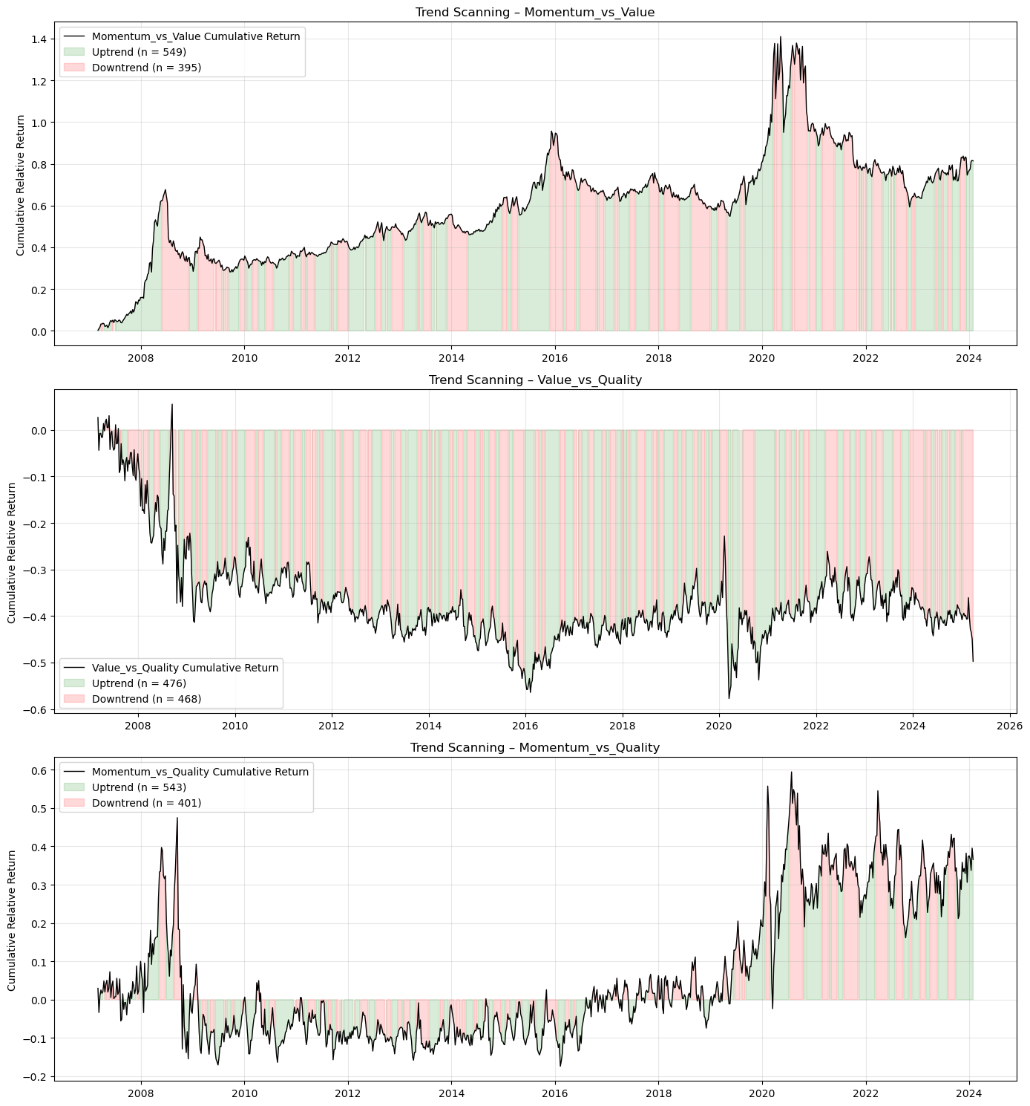
Figure 1: Trend-scanning results each factor pairs

Figure 2 The black line plots the cumulative compounded relative return between the two factors in each pair: momentum and value (top), value and quality (middle), and momentum and quality (bottom). The background shading indicates the trend label obtained from trend scanning. Uptrend (green) and downtrend (red) are assigned based on the maximum absolute t-statistic of the regression slope across candidate forward horizons, following (Lopez de Prado, 2020).

Feature selection
Theoretical literature has yet to establish a unified framework for identifying predictors of factor performance. Consequently, feature selection will rely by both economic theory and data-driven empirical relevance. Guided by recent empirical evidence, the initial feature universe was constructed to include market-based variables, macroeconomic indicators, and fundamental series. An initial feature universe of over 450 variables was constructed, encompassing market-based, macroeconomic, and fundamental indicators.
Recent studies show that price trends, liquidity and volatility are amongst the most informative predictors under normal market conditions with both ML and traditional methods rating them alike (Gu, et al., 2020; Han, 2024). Value and momentum proved to be more robust in both emerging and developed markets (Cakici, et al., 2023). Volatility, technical and sentiment indicators were more crucial during market crisis conditions (Saetia & Yokrattanasak, 2022; Fang, et al., 2022). Macro-economic indicators, by contrast, were not strong predictors within developed markets but showed stronger relevance in emerging markets (Fang, et al., 2022).
To reduce redundancy in the feature space we rely on mutual information (MI) shared between features (Sulaiman & Labadin, 2016; Lopez de Prado, 2018). MI between every pair of features is computed resulting in an MI matrix. To convert the MI matrix into a form suitable for clustering, MI scores are normalized and transformed into a distance matrix. Distance metrics built from information-theoretic measures are more robust in capturing nonlinear functional relationships than classical correlation-based distances (Lopez de Prado, 2018).
Hierarchical agglomerative clustering was applied to this distance matrix using Ward linkage to group features with similar informational content (Krier, et al., 2007). Within each cluster the feature with the lowest average MI-distance to all others in the cluster was retained, reflecting the most informationally central element. Even though the technique can detect nonlinear redundancies, the representative feature is selected based on informational centrality rather than predictive relevance. MI-based methods provide heuristic rather than guaranteed optimal predictive relevance (Beraha, et al., 2019; Liu, et al., 2025).

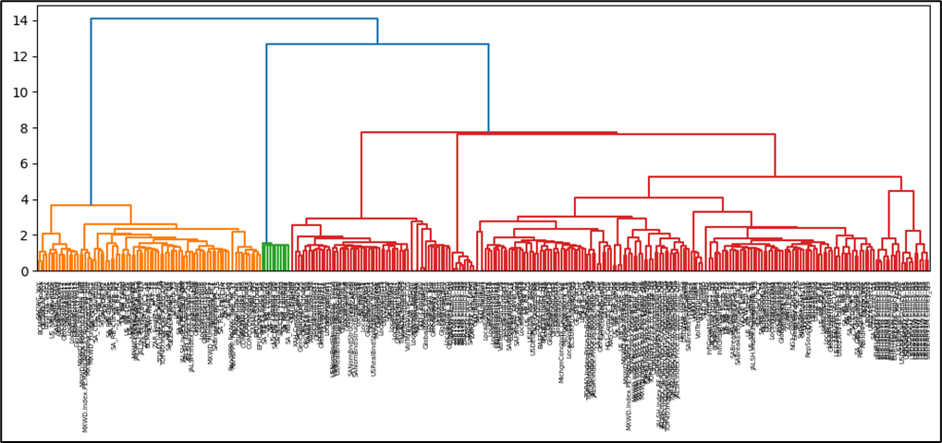
Figure 2: Hierarchical agglomeration clustering applied to the features space

Figure 3 Represents the entire feature space. The ward linkage function is selected for its robustness against elongated clusters. The maximum distance for clusters selection is set at 2, resulting in a total of 32 clusters.
The resulting feature set forms the matrix $X_{t}∈R^{p}$, representing a diversified and compact set of predictors to be used for our modelling tasks.

Table 2: Classification of representative features with associated economic rationale and supporting empirical evidence
Feature Category | Feature | Economic Rationale | Empirical Findings
Momentum | factor_ret_lag4 (x3) | - Assets that have performed well in recent past tend to continue performing. | (Gu et al., 2020)  Momentum signals remain among the strongest predictors in both ML and traditional frameworks.
 | factor_ret_lag12 (x3)
 | corr_momentum_quality_12 | - Measures co-movement between factors identifies convergence/divergence regimes.
 | corr_momentum_value_12
 | corr_value_quality_12
 | zrel_value_vs_quality_12 | - Standardised relative performance useful for detecting style rotation.
 | zrel_momentum_vs_quality_12
 | zrel_momentum_vs_value_12
Price-based features | VolTermStructPC1 | - Captures level of volatility term structure - captures future uncertainty | (Gu et al., 2020)  Volatility consistently ranks among the most important ML predictors.
 | VolTermStructPC2
 | GLD_FracDiff | - Local volatility provides a good signal for risk-on/risk-off environments.
 | GLD_RollSD
 | USDZARV1M.Curncy_QS
 | USDZARV1Y.Curncy_QS
 | GlobalBondVol6 | - Global volatility spills over across international markets.
 | GlobalPropertyVol12
 | EURUSDV6M.Curncy_QS
Fundamental | MXWD_Fundamental_PC1 | - Fundamental valuation measures (P/E, P/B, sales) capture expected mean-reversion in prices.  - Book-to-price differentials identify undervalued vs overvalued stocks.  - Sales-to-price ratio identifies cyclical undervaluation. | (Cakici, et al., 2023)  Value followed by momentum prove to be a crucial driver of stock prices globally
 | JALSH_Fundamental_PC1
 | TOP40.Index.Price.to.Book.Ratio_Diff
 | MXWD.Index.PE.Ratio_QS
 | TOP40.Index.Price.to.Ebitda_Diff
 | JALSH.Index.Price.to.Sales.Ratio_Diff
Sentiment Indicators | MichgnConcIndx | - Reflects household expectations and overall risk sentiment. | (Saetia & Yokrattanasak, 2022)  Technical financial indicators and sentiment indicators showed stronger predictive power than macro-economic indicators.
 | GenComIndexPC1_QS | - Commodity PCA reflects global risk appetite, growth expectations, and inflation pressure.
 | GLD_StructBreak | - Structural breaks in gold prices signal major shifts in global uncertainty.
 | GLD_LempZiev
 | GLD_RollSkew
 | GLD_RollKurt
 | GlobalEquityTS | - Captures momentum in investor optimism/pessimism.
 | GlobalEquity_EntDyn
Macro-economic | SA_RB_Curvature | - Yield curve curvature and slope reflects growth expectations and monetary policy stance (local and global) | (Fang, et al., 2022)  Factor predictability is macro-state dependent.
 | US_RB_Curvature
 | SA_NB_Slope
 | SA_CDS_Slope | - Credit spread slope proxies’ sovereign risk, economic stress, and funding conditions.
 | RandPPP_Factor_Inst_TS_ST | - Tracks widening and narrowing of rand valuation
 | PPP.ZA.Index_QS | - Rand valuation sits relative to its 5-year history.
 | ZAR18M.Curncy_QS | - Captures medium-term USDZAR implied volatility relative to, indicating currency risk conditions.
 | USDZAR_EntDyn | - Information content in FX markets
Factor specific performance | factor_ret_lag4 (x3) | - Assets that have performed well in recent past tend to continue performing. | (Gu et al., 2020)  Momentum signals remain among the strongest predictors in both ML and traditional frameworks.
 | factor_ret_lag12 (x3)
 | corr_momentum_quality_12 | - Measures co-movement between factors identifies convergence/divergence regimes.
 | corr_momentum_value_12
 | corr_value_quality_12
 | zrel_value_vs_quality_12 | - Standardised relative performance useful for detecting style rotation.
 | zrel_momentum_vs_quality_12
 | zrel_momentum_vs_value_12
Factor specific volatility | relvol_momentum_vs_quality_12 | - Identifies instability in factor relative performance | (Kelly, Pruitt & Su, 2019)  Volatility shocks predict style divergence and regime changes.
 | relvol_momentum_vs_value_12
 | relvol_value_vs_quality_12
 | volratio_momentum_quality_12 | - Measures volatility differential driving factor rotations.
 | volratio_momentum_value_12
 | volratio_value_quality_12

Model training

The objective function
Rather than predicting exact return magnitudes, all three models aim to classify whether a factor is expected to lead or lag the other two factors, based on prevailing market and economic conditions. Each model estimates the conditional probability of relative factor outperformance defined as:
$$P(y_{t}=1|X_{t})$$ | ( 4 )
This is achieved by producing a probability score between zero and one:
$${\hat{p}}_{t}∈[0,1]$$ | ( 5 )
A factor timing signal is generated when the probability exceeds a calibrated threshold $(τ)$:
$${\hat{y}}_{t}=1\{{\hat{p}}_{t}≥τ\}$$ | ( 6 )

Logistic regression
The simplicity and direct interpretability of linear models have contributed to their significance in finance. Logistic regression provides a transparent economic interpretation of how each predictor influences the likelihood of factor outperformance. The model assumes a linear relationship between the log-odds of the outcome and the predictor variables (Hosmer, et al., 2013; James, et al., 2021). The model imposes the assumes that the log-odds of a binary outcome are a linear function of the predictor:
$$logit\left(P\left(y_{t} | X_{t}\right)\right)=\ln\left(\frac{P\left(y_{t} | X_{t}\right)}{1-P\left(y_{t} | X_{t}\right)}\right)= β_{0}+X_{t}^{T}β$$ | ( 7 )
Here, $β_{0}$ is the intercept term and $β∈R^{p}$ is a vector of coefficients measuring linear impact of each feature on the log-odds. To obtain a predicted probability from the linear predictor, the inverse of the logit, known as the logistic (sigmoid) function, is used:
$${\hat{p}}_{t}=σ\left(β_{0}+X_{t}^{T}β\right)= \frac{1}{1+e^{-(β_{0}+X_{t}^{T}β)}}$$ | ( 8 )

Model parameters $\left(β_{0}, β\right)$are estimated by minimizing the penalized log-likelihood function.
$$L(β)=\sum_{t∈D_{train}}{w_{t}}\left[-y_{t}\log{{\hat{p}}_{t}}-\left(1-y_{t}\right)\log{(1-{\hat{p}}_{t})}\right]+ λ\left(α∥β∥_{1}+\frac{1-α}{2}∥β∥_{2}^{2}\right)$$ | ( 9 )
where $λ≥0$ controls overall regularization strength and $α∈[0,1]$ trades off LASSO and Ridge penalties. To prevent overfitting and enhance model robustness we penalize the log-likelihood function. The elastic-net regularization is a common feature in financial analysis, which is a hybrid between LASSO and Ridge shrinkage. It mitigates multicollinearity and stabilizes estimates (Zou & Hastie, 2005; Tibshirina, 1996; Gu, et al., 2020):
We implement the logistic regression function using a custom logistic regression function written in Python. The implementation structure follows the theoretical formulation of (Hosmer, et al., 2013; James, et al., 2021). The model computes the logistic (sigmoid) mapping, evaluates the penalized log-likelihood, and performs gradient descent with optional elastic-net regularization (Zou & Hastie, 2005).

Generalized Additive Models (GAMs)
Example Generalized Additive Models (GAMs) introduced by (Hastie & Tibshirani, 1986) extend generalised linear models by introducing nonlinear transformations of the original predictors as new additive terms in an otherwise linear model. This model enables nonlinearity while maintaining transparency. The GAM specification for binary classifications structurally resembles that of the logistic regression. Using the logit transformation, the conditional probability of outperformance is given by:
$$g\left(P\left(y_{t}=1|X_{t}\right)\right)= β_{0}+\sum_{i=1}^{p}{s_{i}(X_{t,i})}$$ | ( 10)
$β_{0}$ is the intercept term and each $s_{i}(.)$ is a smooth, potentially nonlinear function capturing the marginal effect of predictor $(X_{t,i})$ (Hastie & Tibshirani, 1986). The predicted probability for classification is given by:
$${\hat{p}}_{t}=σ\left(β_{0}+ \sum_{i=1}^{p}{s_{i}\left(x_{t,i}\right)}\right)$$ | (11)
Each smooth $s_{i}(.)$ is represented via a basis expansion: $s_{i}\left(x\right)=B_{i}{(x)}^{T}θ_{i}, B_{i}\left(x\right)∈R^{k_{i}}$,
$B_{i}\left(x\right)$ is a vector of spline basis function, which control the functional relationship between a predictor variable and a conditional response, whose coefficients $\left\{θ_{i}\right\}$ must be estimated. The size of the basis expansion limits the smoothing spline’s potential complexity with a larger set of basis functions allowing greater flexibility. We use cubic splines with $k_{i}$ controlling the flexibility of each smoothing term. Given that each spline $s_{i}(.)$ can be visualised independently, spline bases enable GAMs to model nonlinearity while maintaining additive interpretability (James, et al., 2021).
We estimate the coefficients $\left\{θ_{i}\right\}$ and $β_{0}$ by minimizing:
$$L\left(S\right)=\sum_{t∈D_{train}}{w_{t}\left[{-y}_{t}\log{{\hat{ p}}_{t}}-\left(1-y_{t}\right)\log{(1-{\hat{p}}_{t})}\right]}+ \sum_{i=1}^{p}{λ_{i}θ_{i}^{T}S_{i}θ_{i}}$$ | (12)

The smoothness of the spline is controlled by a smoothing penalty $(λ_{i})$ and ${(S}_{i})$ is the spline penalty matrix (Hastie & Tibshirani, 1986).

Extreme Gradient Boost (XGBoost)
Tree-based ML models are non-parametric and use logic that departs markedly from traditional econometric models to capture nonlinearities within the data. These models build on the concept of decision trees, where binary groups are created by grouping observations with similar characteristic. They use a hierarchical tree structure that partitions the predictor space by recursively selecting features and splits that maximize a set improvement criterion such as information gain, entropy reduction, Gini reduction, or variance reduction depending on the task (Breiman, et al., 1984; Hastie & Friedman, 2009). This process ensures that the most informative features for predicting the target are placed higher in the tree structure.
Although decision trees are intuitive, single CART (classification and regression tress) easily overfit (Hastie & Friedman, 2009; Breiman, et al., 1984; Gu, et al., 2020). Ensemble methods like bagging and boosting address this shortcoming by combining multiple weak learners (Friedman, 2001; L, 1996). This study focuses specifically on a boosting ensemble that build a strong predictive model by sequentially combining many weak learners. XGBoost construct an additive model of the form:

$$F_{M}\left(X_{t}\right)=\sum_{m=1}^{M}{f_{m}\left(X_{t}\right), } f_{m}∈F$$ | (13)
where each $f_{m}$ is a classification and regression trees (CART) (Chen & Guestrin, 2016). For binary classification, the ensemble output is mapped to probabilities using the logistic sigmoid function given by:
$${\hat{p}}_{t}= σ\left(F_{M}\left(X_{t}\right)\right), σ\left(x\right)= \frac{1}{(1+e^{-x})}$$ | (14)

At each boosting iteration $(m)$, we aim to minimize:
$$L^{(m)}=\sum_{t∈D_{train}}{w_{t}}l\left(y_{t},{\hat{p}}_{t}^{\left(m-1\right)}+f_{m}\left(X_{t}\right)\right)+Ω\left(f_{m}\right)$$ | (15)
Where the logistic loss function defined as:
$$l\left(y,p\right)=-y\log{p}-\left(1-y\right)\log{(1-p)}$$ | (16)
and tree regularization function given by:
$$Ω\left(f\right)=γT+\frac{λ}{2}\sum_{j=1}^{T}{w_{j}^{2}}$$ | (17)
$(T)$ is the number of leaves and ${(w}_{j})$ the leaf weight. Each tree is trained to fit the residuals of the previous iteration, allowing the ensemble to progressively correct its errors.

In study, XGBoost model is trained using the xgboost python library. This implementation executes the theoretical additive tree-boosting framework described (Chen & Guestrin, 2016).

Table 3 Model comparison
Model | Model Complexity | Interpretability | Strengths | Limitations / Risks | Key Hyperparameters | References
Logistic Regression | Low | High | Transparent coefficients (economic interpretability); | Misses nonlinearities; | Maximum iterations (max_iter) | Hosmer & Lemeshow (2013)  Logistic regression formulation;  Zou & Hastie (2005)  Regularization for high dimensional settings
 |  |  | Efficient with small samples; | Sensitive to multicollinearity; | Regularization strength (λ)
 |  |  | Robust to noise with regularization | Limited predictive power in complex regimes | L1/L2 mixing ratio (α)
 |  |  |  |  | Solver tolerance (tol)
Generalized Additive Model (GAM) | Moderate | Moderate–High | Captures smooth nonlinear effects; | Cannot easily model interactions; | Number of splines (n_splines) | Hastie & Tibshirani (1986);  GAM formulation  Wood (2017);  Gu, Kelly & Xiu (2020)
 |  |  | Retains partial interpretability; | Computationally heavier; | Smoothness penalty (λ_i)
 |  |  | Controls overfitting via smoothing penalty | Requires careful selection of smoothing parameters | Maximum iterations (max_iter)
Extreme Gradient Boosting (XGBoost) | High | Low | Captures high-order nonlinearities and interactions; | Reduced interpretability; | Learning rate (η) | Friedman (2001);  Chen & Guestrin (2016);  Krauss, Do & Huck (2017)
 |  |  | Inherent feature selection via splits | Prone to overfitting without tuning; | Maximum tree depth (max_depth)
 |  |  |  | Sensitive to hyperparameter configuration | Subsample ratio (subsample)
 |  |  |  |  | Number of boosting rounds (n_estimators)
 |  |  |  |  | Regularization (λ, γ)

Hyperparameter tuning and model validation

Combinatorial Cross-Purged Validation
The choice of hyperparameters controls the model’s complexity, limiting the potential for overfitting. Applying the foundational framework of (Lopez de Prado, 2018), model hyperparameters are optimized via combinatorial purged cross-validation (‘CPCV’ hereafter).
CPCV generates multiple unique combinations of training and testing sets, ensuring that each block of samples appears the same number of times in the training set. To ensure that the validation set performance is still a good proxy for the performance on unseen data, samples in the validation set need to be reasonably independent from those in the training set. (Lopez de Prado, 2018) achieves this by remove any training data whose information horizon overlaps with the validation set (i.e. purging).
 | No. of splits | No. of weeks
Cross-validation (CV) splits | 5 | 185 (per split)
Test split | 1 | 185 (per split)
Look back window |  | 360
Purge gap |  | 12

For our analysis, we used a maximum look-ahead window of 12 weeks when assigning trend labels to our target variable, meaning that the purge gap should be at least the size of the look-ahead window to mitigate look-ahead bias. Parameters are then optimized on the generated blocks. We select the parameter set with the highest predictive score on the unseen validation set as input to the walk-forward validation phase. To accommodate evolving market regimes and non-stationarity, parameters are re-tuned annually.
Table 4
Model | No. of test parameter combinations | Key hyperparameters | Tuning parameter grid
Logistic | 243 | Learning rate (η) | [ 0.01 , 0.05 , 0.10 ]
 |  | Maximum iterations | [ 500 ,1000 , 2000 ]
 |  | Regularization strength (λ) | [ 0 , 0.1 , 0.01 ]
 |  | L1/L2 mixing ratio (α) | [ 0 , 0.5 , 1 ]
 |  | Base score | [ 0.5 , 0.6 , 0.7 ]
GAM | 12 | Number of splines | [ 3 , 7 , 8 ]
 |  | Smoothness penalty (λ) | [ 0.1 , 1 , 10 , 25 ]
 |  | Fit intercept | TRUE
 |  | Maximum iterations | [ 200 ]
XGBoost | 243 | Learning rate (η) | [ 5 , 7 , 10 ]
 |  | Maximum tree depth | [ 3 , 6 , 10 ]
 |  | Subsample ratio | [ 0.6 , 0.8 , 1 ]
 |  | Regularization (λ, γ) | [ 0.6 , 0.8 , 1 ]
 |  | Base score | [ 0.5 ,0.6 , 0.7 ]

Walk forward Cross-Validation
Validation is the process of evaluating how well a model performs on unseen data, ensuring it can generalize beyond the data it was trained on. Developing machine learning models for time series data requires special care, mainly because the usual machine learning assumption of samples being independent and identically distributed (IID) generally does not hold. Time series data often contain autocorrelations, seasonal patterns, trends, and other temporal dependencies that make neighbouring observations anything but independent. Commonly used cross-validation techniques like k-fold validation can lead to data leakage, where a model ignores the temporal order of observations and uses future data to make predictions resulting in overly optimistic performance estimates. Walk-forward validation involves iteratively training a model on historical data and then evaluate its performance on subsequent data that lies chronologically after the training data. It ensures that the model is always trained on past data and evaluated on future data, preventing data leakage and providing a more realistic assessment of forecasting ability. Furthermore, the repeated training and evaluation helps identify patterns in data that change overtime.

Performance evaluation
After the training phase, models produce predictions for the binary outcome indicating whether a factor is expected to outperform or underperform in the subsequent period. We will explore classical classification evaluation metrics (i.e. recall, precision, F1 etc) with a specific emphasis on three complementary performance measures that evaluate directional accuracy, confidence in the predicted class label and ranking quality of the different models. This offers a balanced assessment of how often the model makes accurate predictions, how well it separates outperformance from underperformance and, how well the probabilities are calibrated.

Directional accuracy - Average Accuracy
Average accuracy is a common measure of predictive accuracy which measures the proportion of correct predictions against:
$$Average Accuracy= \frac{TP+TN}{TP+FP+TN+FN}$$
Average accuracy provides directional correctness and forms a good baseline to evaluate performance. We extend our performance analysis to also explore the confidence and ranking of the predicted class label.

Confidence in predictions – Log loss
Log loss evaluates the accuracy and quality of predicted probabilities in binary classification problems. It measures how well a model assigns high probability to the true class and penalizes confident but incorrect predictions.
$$Log loss= -\frac{1}{N}\sum_{t=1}^{N}{\left[y_{t}\log\left({\hat{p}}_{t}\right)+(1-y_{t})log⁡(1-{\hat{p}}_{t} )\right]}$$
A lower log loss indicates better probabilistic predictions.

Ranking quality of model - Receiver operation characteristics area under curve (ROC AUC):

The ROC curve measures the model’s discrimination ability defined as the model’s ability to assign higher predicted probabilities to positive observations than negative ones. It visualizes the trade-off between the true positive rate (TPR), also known as sensitivity or recall, and the false positive rate (FPR). A model with strong discrimination will achieve higher TPR while maintaining low FPR resulting in an ROC curve bends sharply towards the upper-left corner. The area under the ROC curve summarizes this discrimination into a single figure between zero and one. High ROC AUC implies the model consistently assigns higher predicted probabilities to periods that genuinely outperform. Figure 3 Illustrative the trade-off between TPR and FPR across varying classification thresholds, and how the ROC AUC is calculated and represented.
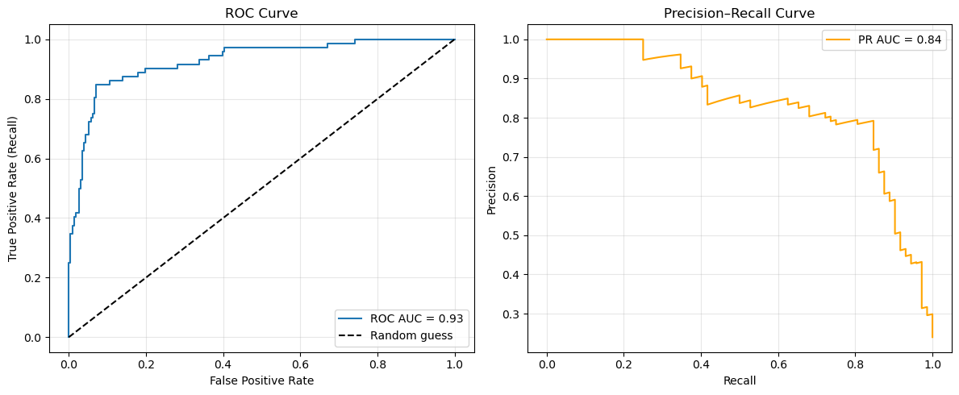
Figure 3: Illustrative ROC curve showing the trade-off between TPR and FPR across varying classification thresholds.

Feature Importance

Conclusion

Results

Factor behaviour
This section examines the historical behaviour of the momentum, value, and quality factors in the South African equity market, focusing on their unconditional and conditional return characteristics, as well as the stability of their co-movement over time. The analysis draws on both cumulative return profiles and rolling 12-month returns to illustrate long-run performance, time-varying volatility, and regime-dependent dynamics. Understanding these properties is a necessary precursor to the application of conditional factor-timing models in later sections.

Unconditional Factor Returns
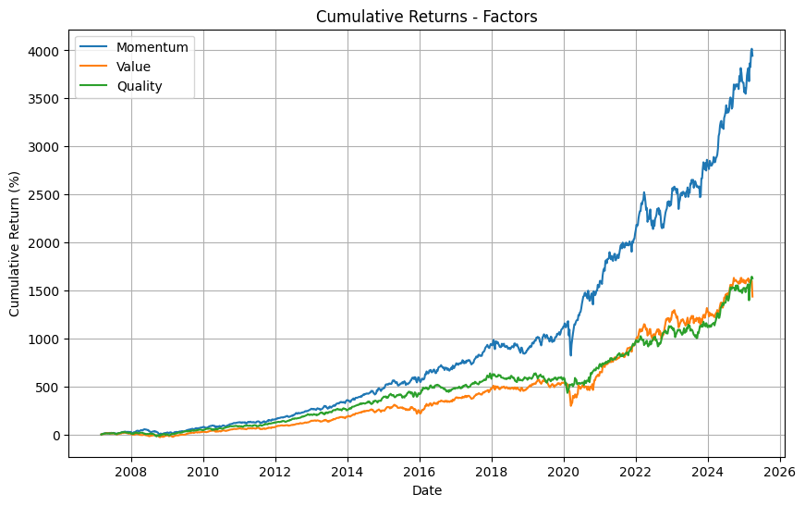
Figure 4: Cumulative factor returns
Figure 4 presents the cumulative returns of the momentum, value, and quality factors over the full sample period. Momentum delivers the strongest long-run performance, exhibiting sustained compounding punctuated by episodic drawdowns. Quality and value generate more moderate cumulative returns, with quality displaying a smoother return trajectory relative to value.
The cumulative profiles highlight path dependency across all factors. Periods of strong outperformance are interspersed with prolonged drawdowns, particularly for momentum and value. This indicates that factor premia are not realised uniformly through time, and that long-run averages mask significant intra-period variation. As such, unconditional performance alone provides an incomplete representation of factor behaviour.

Unconditional Volatility and Return Dispersion
While cumulative returns summarise long-run outcomes, Figure 5 illustrates the evolution of 12-month rolling returns, providing insight into the variability of factor performance. All three factors exhibit pronounced time-variation in returns, with clear evidence of volatility clustering and asymmetric downside risk.
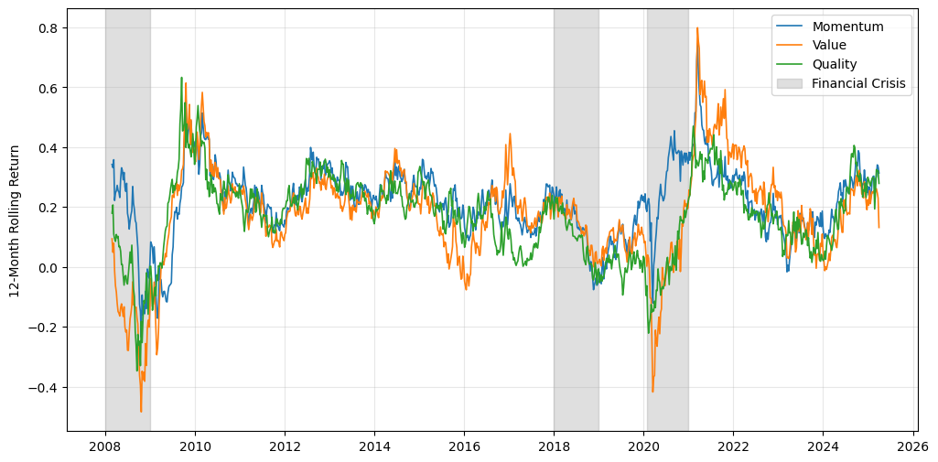
Figure 5: 24-month rolling factor returns
Momentum displays the widest dispersion in rolling returns, reflecting its sensitivity to sharp market reversals. Value exhibits deep negative rolling returns during market stress episodes, followed by periods of strong recovery, consistent with its cyclical and contrarian nature. Quality, by contrast, demonstrates comparatively lower volatility and shallower drawdowns, reinforcing its defensive characteristics.
These patterns suggest that factor returns are heteroskedastic even in an unconditional sense, violating assumptions of constant variance and highlighting the importance of modelling time-varying risk

Conditional Behaviour Across Market Regimes
The rolling return profiles further reveal that factor performance is strongly conditioned on market regimes. During periods of market stress, such as the Global Financial Crisis and the COVID-19 shock (shaded regions in Figure 4.1), factor behaviour diverges markedly.
Momentum experiences sharp drawdowns during abrupt market reversals but rebounds strongly during subsequent recoveries, indicating high sensitivity to trend persistence and regime shifts. Quality exhibits relative resilience during stress periods, with smaller negative rolling returns, consistent with its emphasis on financial strength and earnings stability. Value underperforms most severely during downturns, reflecting its exposure to cyclical earnings and distressed valuations, but tends to recover during expansionary phases.

These regime-dependent dynamics suggest that factor returns are state-contingent rather than static, motivating the exploration of conditional frameworks capable of adapting exposures over time.

Factor Co-movement and Stability of Co-relationships
Beyond
Beyond individual factor dynamics, the joint behaviour of Momentum, Value, and Quality reveals that factor co-movement is neither constant nor negligible over time. Evidence from cumulative return trajectories and rolling 12-month returns indicates that the strength and direction of inter-factor relationships vary meaningfully across market regimes, consistent with prior findings in both developed and emerging markets (Ang & Timmermann, 2012; Ilmanen, 2011).
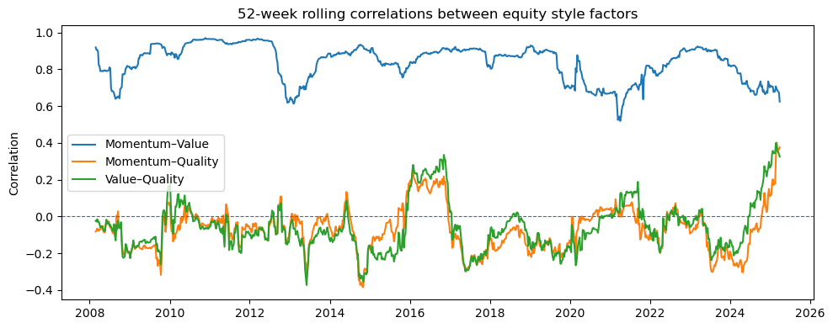
During periods of market stress—most notably the Global Financial Crisis and the COVID-19 shock—rolling factor returns display heightened synchronisation, with all three factors experiencing simultaneous drawdowns or recoveries. This pattern suggests a temporary increase in exposure to common systematic risk factors, leading to elevated correlations and a deterioration in diversification benefits, a phenomenon widely documented during crisis regimes (Longin & Solnik, 2001; Forbes & Rigobon, 2002). In contrast, during recovery and expansionary phases, factor returns become more dispersed, reflecting greater differentiation in factor performance and reduced co-movement (Ilmanen & Kizer, 2012).

Rank-based dependence measures further clarify the nature of these relationships. The strong positive monotonic association observed between Momentum and Value indicates that these factors tend to outperform and underperform jointly across large portions of the sample, despite differing economic interpretations. Such co-movement may reflect shared sensitivity to macro-financial conditions, valuation cycles, and capital flow dynamics, particularly in markets characterised by concentrated index structures and episodic liquidity constraints (Cakici et al., 2013; Hou et al., 2015). By contrast, both Momentum–Quality and Value–Quality pairs exhibit near-zero rank correlation, implying that Quality operates as a relatively orthogonal return source, consistent with its grounding in firm-level profitability, balance-sheet strength, and earnings stability rather than price-based dynamics (Asness et al., 2019).

Importantly, the persistence of this dependence structure across both Spearman’s ρ and the more conservative Kendall’s τ suggests that these relationships are structural rather than driven by outliers or extreme observations, strengthening the robustness of the findings (Conover, 1999; Kendall, 1970). This distinction is particularly relevant in financial return series, which are characterised by non-normality, heteroskedasticity, and regime shifts.
Taken together, these results indicate that average correlations provide an incomplete and potentially misleading summary of factor interactions. While unconditional dependence measures suggest moderate to strong co-movement between certain factor pairs, rolling return evidence demonstrates that such relationships intensify during stress regimes and weaken during more benign market conditions. Similar patterns of regime-dependent factor dependence have been documented in the broader factor investing literature (Ang & Bekaert, 2002; Ilmanen, 2011).

The instability of inter-factor relationships has important implications for multi-factor portfolio construction and risk management. In particular, periods of elevated co-movement reduce the effectiveness of naïve diversification, while phases of low dependence create opportunities for relative performance differentiation. These findings reinforce the view that factor interactions are state-contingent, evolving alongside broader market and liquidity conditions, and motivate the adoption of conditional modelling frameworks capable of adapting to such dynamics (López de Prado, 2018; Gu et al., 2020).
Taken together, the evidence from cumulative and rolling return analysis indicates that factor returns in the South African equity market are characterised by time-varying expected returns, volatility, and correlations. Unconditional performance metrics obscure conditional structure, while static factor allocations fail to account for regime-dependent dynamics.
These observations provide a strong empirical motivation for factor-timing approaches that condition factor exposures on evolving market information. The next sections build on these insights by formalising the factor-timing problem within a supervised learning framework and evaluating whether observable predictors can be used to identify periods of relative factor outperformance.

Out-of-Sample predictive power
We assess the robustness of the model using three main complimentary performance measures; directional accuracy – average accuracy, discrimination ability – ROC AUC, and probability reliability – log-loss. Table 3 shows the out of sample predictive accuracy of the three models across the three factor pairings. The hierarchical model design is effective in demonstrating that increased model complexity yields significant predictive benefits. XGBoost consistently delivers the best performance across all factor metrics for momentum vs value and momentum vs quality factor pairs. This reinforces prior studies that ML methods capture complex nonlinear interaction overlooked by linear models (Shihao, et al., 2020; Chen, et al., 2019). The strong ROC AUC score and average accuracy emphasize the model’s ability to make directional predictions and a robust ability to classify the superior the superior factor. The GAM provides modest improvements from linear models, achieving consistently higher average accuracy and discretionary power particularly in momentum vs value and momentum vs quality. This confirms that introducing smooth linearities provides an incremental benefit over linear models. The significant difference between GAM and XGBoost suggests that curvature without interaction modelling produces diminishing returns. The logistic regression yields the least directional accuracy and discriminatory ability as evidenced by low ROC AUC scores across factor pairs, suggest that the linear relationships it assumes are insufficient to capture the full dynamics of factor outperformance in this market. While the logistic regression is the weakest performer, its scores are often above 0.5 indicating it does capture some informative, linear signal.
Table 5: Out-of-sample average accuracy of the three models across the three factor pairings.
Average Accuracy | Logistic | GAM | XGBoost
Momentum vs Value | 59.6% | 62.2% | 75.0%
Momentum vs Quality | 55.4% | 59.6% | 68.9%
Value vs Quality | 65.4% | 60.9% | 65.4%

Table 6: Out-of-sample log-loss
Log-loss | Logistic | GAM | XGBoost
Momentum vs Value | 0.72 | 0.77 | 0.82
Momentum vs Quality | 0.71 | 0.90 | 0.93
Value vs Quality | 0.70 | 0.92 | 0.95

Table 7:
Momentum vs Value | Momentum vs Quality | Value vs Quality
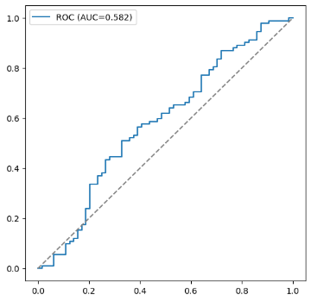 | 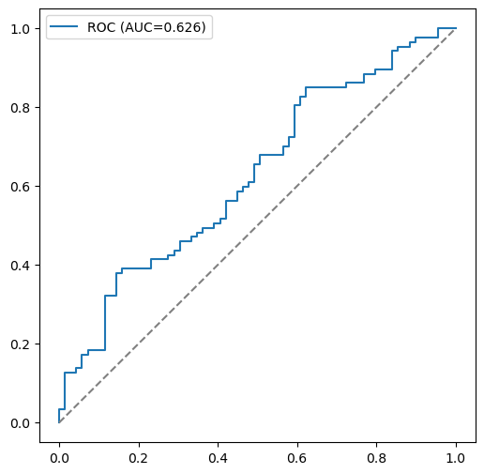 | 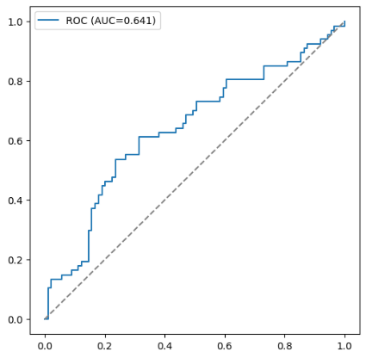
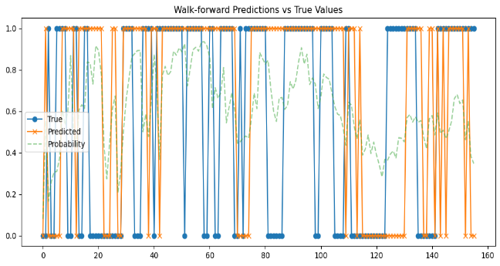 | 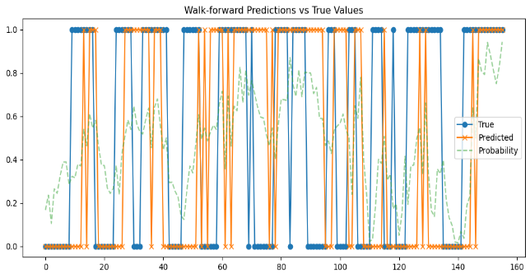 | 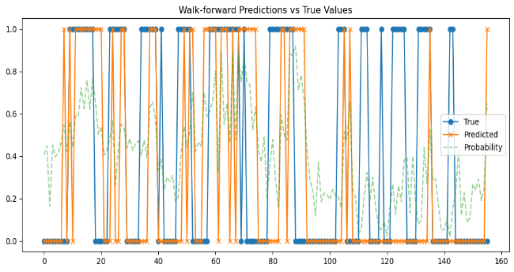
Table 8:
Momentum vs Value | Momentum vs Quality | Value vs Quality
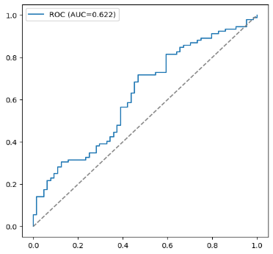 | 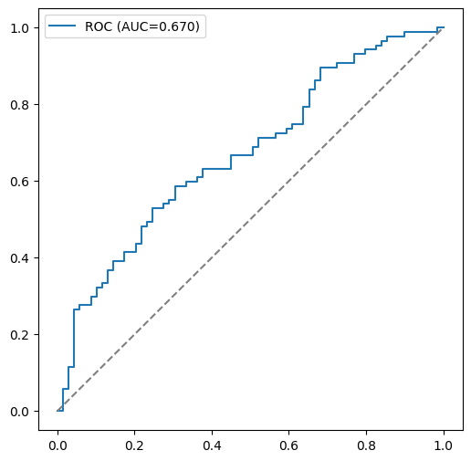 | 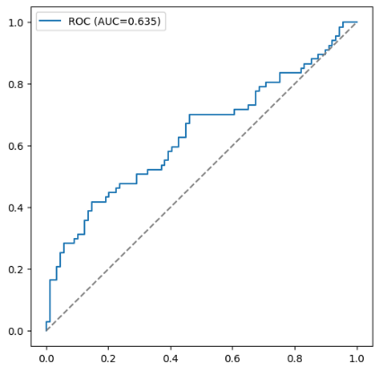
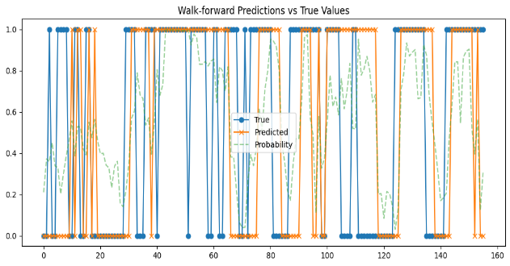 | 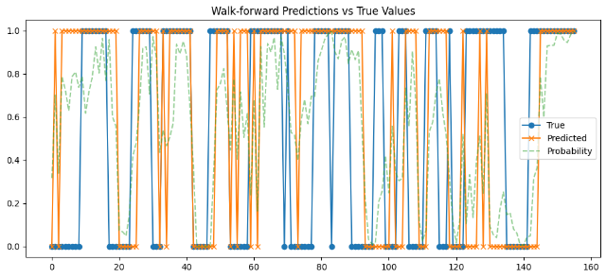 | 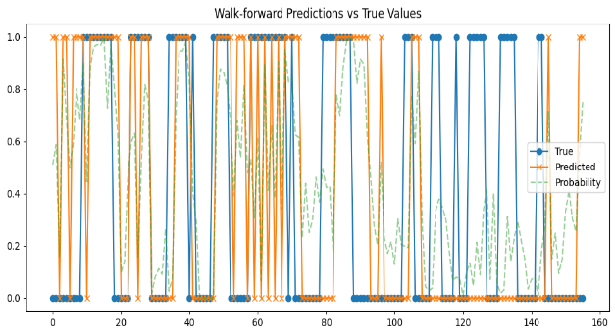
Table 9:
Momentum vs Value | Momentum vs Quality | Value vs Quality
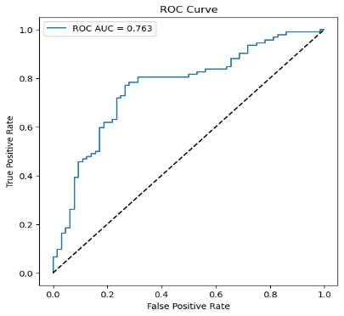 |  |  | 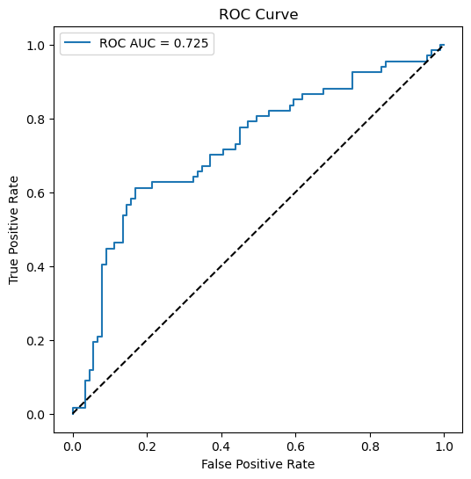
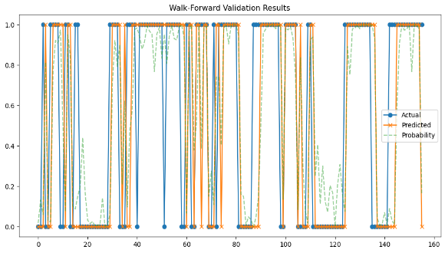 | 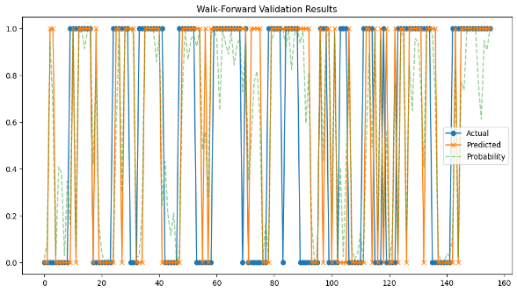 |  | 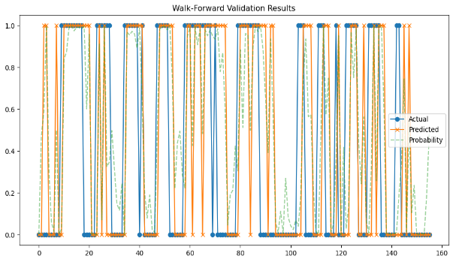

Easiest and hardest factor pairs
Table 10:
Factor Pair | Model | F1 Score | Recall | Precision
 | Logistic | 0.6900 | 0.7610 | 0.6310
Momentum vs Value | GAM | 0.6780 | 0.6740 | 0.6810
 | XGBoost | 0.7850 | 0.7720 | 0.7980
 | Logistic | 0.5590 | 0.5170 | 0.6080
Momentum vs Quality | GAM | 0.6560 | 0.6900 | 0.6250
 | XGBoost | 0.7290 | 0.7590 | 0.7020
 | Logistic | 0.5340 | 0.4630 | 0.6330
Value vs quality | GAM | 0.5270 | 0.5070 | 0.5480
 | XGBoost | 0.6140 | 0.6420 | 0.5890

The performance varies significantly across factor pairs. Momentum vs Value is consistently the most predictable relationship. XGBoost achieves impressive scores (Accuracy: 0.750, F1: 0.785, AUC: 0.763). This is the strongest result suggesting the drivers of momentum against value have strong predictive patterns that can be captured by using ML. Momentum against quality shows moderate predictability. XGBoost performance drops slightly (F1: 0.729, AUC: 0.740). The least predictable factor pair for all models. Even though the XGBoost's accuracy (0.654) is better than a random guess, and its F1 score (0.614) is notably low. This low F1 score, coupled with low Precision (0.589), indicates the model struggles specifically with correctly identifying the periods of outperformance. The high Log Loss also points to less confident, noisier predictions. The value and quality dynamics in South Africa may be dominated by market-specific idiosyncrasies consistent with (Cakici, et al., 2023) who note that model reliability is highly sensitive to market maturity and local risk structure

Feature Importance
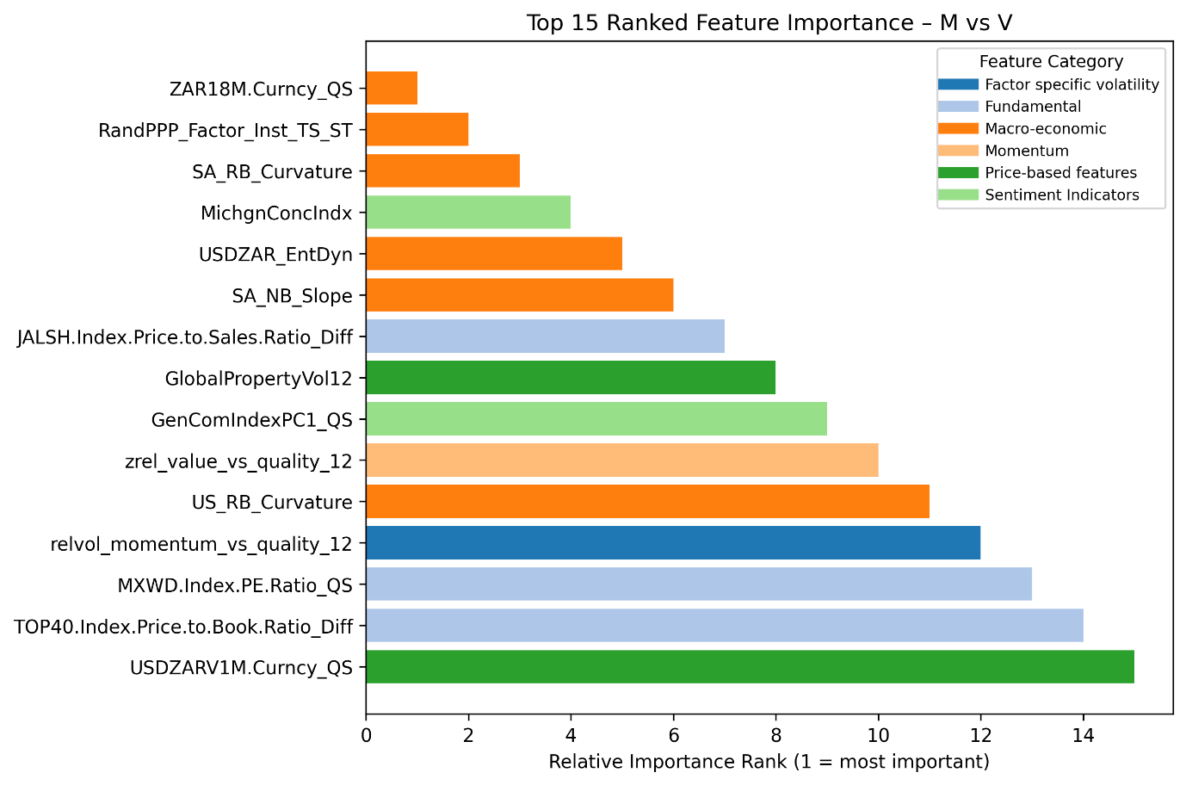
The Momentum–Value classification is characterised by a strong presence of macro-economic and currency-related variables, including exchange-rate dynamics and yield-curve slope and curvature measures. Fundamental valuation spreads, such as price-to-book and price-to-earnings differentials, also appear among the most influential predictors, though they are generally secondary to macro-financial indicators. This pattern suggests that Momentum–Value rotation in the South African equity market is heavily conditioned by macroeconomic regimes and external capital-flow dynamics, consistent with the sensitivity of emerging markets to global financial conditions (Bekaert & Harvey, 2003; Ilmanen, 2011).

In contrast, the Momentum–Quality classification is dominated by relative momentum signals and global uncertainty indicators, with multiple features capturing cross-factor spreads and higher-order dynamics. The prominence of these variables indicates that Momentum–Quality timing is primarily driven by changes in market state and risk environment rather than by slow-moving valuation fundamentals. This finding aligns with the view that Quality strategies exhibit defensive characteristics, leading to regime-dependent interactions with Momentum during periods of heightened volatility or macroeconomic stress (Asness, Frazzini & Pedersen, 2019).
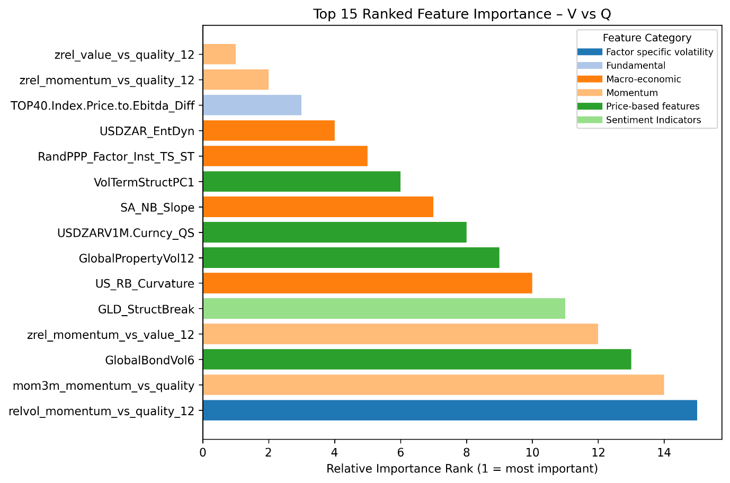

The Value–Quality comparison exhibits a more balanced distribution of feature categories. Macro-economic indicators, valuation measures, and relative factor signals all contribute meaningfully to the classification task. This suggests that the relative performance of Value and Quality is shaped by broader macro-financial conditions rather than a single dominant economic channel. Such behaviour is consistent with evidence that both styles respond to regime shifts in interest rates, growth expectations, and risk premia, albeit through different transmission mechanisms (Fama & French, 2015; Ilmanen & Kizer, 2012).

Overall, the feature importance analysis highlights the state-dependent nature of factor performance in the South African equity market and underscores the importance of incorporating macro-financial and cross-factor information when designing factor-timing strategies.

Validation methodology impact

Table 10: Logistic
 | Walk-forward Period |  | Best Parameter Combinations
 | Start | End | ROC AUC | L1/L2 mixing ratio (α) | Base score | Regularization strength (λ) | Learning rate | No. of iterations
 | 2022-04-11 | 2023-04-10 | 0.532 | 0 | 0.6 | 0 | 0.01 | 2000
Momentum vs Value | 2023-04-10 | 2024-04-08 | 0.519 | 0 | 0.7 | 0 | 0.05 | 500
 | 2024-04-08 | 2025-04-07
 | 2022-04-11 | 2023-04-10 | 0.518 | 0 | 0.5 | 0 | 0.01 | 500
momentum_vs_quality | 2023-04-10 | 2024-04-08 | 0.589 | 0 | 0.7 | 0 | 0.01 | 500
 | 2024-04-08 | 2025-04-07 | 0.561 | 0 | 0.7 | 0 | 0.05 | 2000
 | 2022-04-11 | 2023-04-10 | 0.546 | 0 | 0.5 | 0 | 0.01 | 500
value_vs_quality | 2023-04-10 | 2024-04-08 | 0.646 | 0 | 0.5 | 0 | 0.05 | 1000
 | 2024-04-08 | 2025-04-07 | 0.592 | 0 | 0.5 | 0 | 0.05 | 1000

Table 11: GAM
 | Walk-forward Period |  | Best Parameter Combinations
 | Start | End | ROC AUC | No. of splines | Smoothness penalty (λ) | Maximum iterations
 | 2022-04-11 | 2023-04-10 | 0.564 | 10 | 10
Momentum vs Value | 2023-04-10 | 2024-04-08 | 0.541 | 5 | 100
 | 2024-04-08 | 2025-04-07 | 0.607 | 5 | 100
 | 2022-04-11 | 2023-04-10 | 0.491 | 5 | 300
Momentum vs Quality | 2023-04-10 | 2024-04-08 | 0.617 | 7 | 100
 | 2024-04-08 | 2025-04-07
 | 2022-04-11 | 2023-04-10 | 0.535 | 7 | 10
Value vs Quality | 2023-04-10 | 2024-04-08 | 0.659 | 5 | 300
 | 2024-04-08 | 2025-04-07 | 0.594 | 7 | 10

Table 12: XGBoost
 | Walk-forward Period |  | Best Parameter Combinations
 | Start | End | ROC AUC | Base score | Colsample_bytree | Learning rate | Max depth | Subsample
 | 2022-04-11 | 2023-04-10 | 0.584 | 0.6 | 0.8 | 0.1 | 3 | 0.6
Momentum vs Value | 2023-04-10 | 2024-04-08 | 0.555 | 0.5 | 0.6 | 0.5 | 6 | 1
 | 2024-04-08 | 2025-04-07 | 0.617 | 0.6 | 0.8 | 0.5 | 3 | 0.6
 | 2022-04-11 | 2023-04-10 | 0.558 | 0.5 | 1 | 0.5 | 10 | 0.6
momentum_vs_quality | 2023-04-10 | 2024-04-08 | 0.602 | 0.6 | 1 | 0.5 | 6 | 0.6
 | 2024-04-08 | 2025-04-07 | 0.636 | 0.7 | 0.6 | 0.5 | 3 | 0.6
 | 2022-04-11 | 2023-04-10 | 0.547 | 0.5 | 1 | 0.5 | 10 | 0.8
value_vs_quality | 2023-04-10 | 2024-04-08 | 0.615 | 0.5 | 1 | 0.1 | 3 | 1
 | 2024-04-08 | 2025-04-07 | 0.594 | 0.7 | 1 | 0.5 | 6 | 0.6

Conclusion

References
[1] | Y. Han, “Machine Learning Based Portfolio Analysis,” Highlights in Business, Economics and Management, vol. 44, no. 1, p. 1, 2024.
[2] | K. Saetia and J. Yokrattanasak, “Stock Movement Prediction Using Machine Learning Based on Technical Indicators and Google Trend Searches in Thailand,” International Journal of Financial Studies, vol. 11, no. 5, p. 1, 2022.
[3] | Y. Fang, Y. Chen and H. Ren, “A Factor Pricing Model Based on Machine Learning Algorithm,” Social Science Research Network, vol. 1, no. 1, p. 1, 2022.
[4] | N. Sulaiman and J. Labadin, “Improved Feature Selection Based on Mutual Information for Regression Tasks,” Indonesian Journal of Electrical Engineering and Computer Science, vol. 4, no. 1, pp. 95-104, 2016.
[5] | M. Lopez de Prado, Advances in Financial Machine Learning, 1 ed., New York: John Wiley & Sons, 2018.
[6] | C. Krier, D. François, F. Rossi and M. Verleysen, “Feature clustering and mutual information for the selection of variables in spectral data,” Bruges, 2007.
[7] | M. Beraha, A. M. Metelli, M. Papini, A. Tirinzoni and M. & Restelli, “Feature Selection via Mutual Information: New Theoretical Insights,” Bologna and Italy., 2019.
[8] | S. Liu, J. Li, D. Liu and T. Wen, “Improving Mutual Information based Feature Selection by Boosting Unique Relevance,” Journal of Artificial Intelligence Research, vol. 82, no. 1, pp. 129-156, 2025.
[9] | D. Hosmer, S. Lemeshow and R. Sturdivant, Applied Logisitc Regression, 3 ed., Hoboken: Wiley, 2013.
[10] | G. James, D. Witten, T. Hastie and R. Tibshirani, An Introduction to Statistical Learning, 2 ed., New York: Springer, 2021.
[11] | H. Zou and T. Hastie, “Regularization and variable selection via the elastic net,” Journal of the Royal Statistical Society: Series B (Statistical Methodology), vol. 67, no. 2, pp. 301-320, 2005.
[12] | R. Tibshirina, “Regression shrinkage and selection via the lasso,” ournal of the Royal Statistical Society: Series B, vol. 58, no. 1, pp. 267-288, 1996.
[13] | T. J. Hastie and R. Tibshirani, “Generalized Additive Models,” Statistical Science, vol. 1, no. 3, pp. 297-310, 1986.
[14] | L. Breiman, F. J, O. R and S. C, Classification and Regression Trees, 1 ed., New York: Chapman and Hall/CRC, 1984.
[15] | T. T. R. Hastie and J. Friedman, The Elements of Statisitcal Learning, 2 ed., New York: Springer, 2009.
[16] | J. Friedman, “Greedy function approximation: A gradient boosting machine.,” The Annals of Statistics, vol. 29, no. 5, pp. 1189-1232, 2001.
[17] | B. L, “Bagging Predictors,” Machine Learning, vol. 24, no. 2, pp. 123-140, 1996.
[18] | T. Chen and C. Guestrin, “XGBoost: A Scalable Tree Boosting System,” San Francisco, 2016.
[19] | M. N. i. Alonso and V. Zoonekynd, “Equity Machine Factor Models,” Social Science Research Network, Abu Dhabi, 2022.
[20] | H. Wu, X. Wei and X. Zhang, “Are Stock Returns Predictable in China? A Machine Learning Approach,” SSRN, vol. 1, no. 1, p. 1, 2021.
[21] | W. Wang, “A comparative study of traditional linear models and nonlinear neural network model on asset pricing,” China, 2023.
[22] | O. Tobek and M. Hronec, “Does It Pay to Follow Anomalies Research? Machine Learning Approach with International Evidence,” Journal of Financial Markets, vol. 58, no. 2021, p. 1, 2021.
[23] | A. Shleifer and R. W. Vishny, “The limits of arbitrage,” The Journal of Finance, vol. 52, no. 1, pp. 35-55, 1997.
[24] | W. Sharpe, “Capital asset prices: A theory of market equilibrium under conditions of risk,” The Journal of Finance, vol. 19, no. 3, pp. 435-442, 1964.
[25] | M. Piovezan and J. de Andrea Jr., “Machine Learning Method for Return Direction Forecast of Exchange Traded Funds (ETFs) Using Classification and Regression models,” Journal of Asset Management,, vol. 23, no. 4, pp. 321-337, 2022.
[26] | J. D. Piotroski, “Value Investing: The Use of Historical Financial Statement Information to Separate Winners from Losers.,” Journal of Accounting Research, vol. 38, no. 1, pp. 1-41, 2000.
[27] | L. Mukoyi and K. Ogujiuba, “Comparison of Multifactor Asset Pricing Models in the South African Stock Market [2000–2016],” Journal of Risk and Financial Management, vol. 16, no. 4, p. 1, 2023.
[28] | B. Moritz and T. Zimmermann, “Tree-Based Conditional Portfolio Sorts: The Relation Between Past and Future Stock Returns.,” SSRN Electronic Journal., 2016.
[29] | S. Makamo, “Predicting Style Factor Returns and Group/sector Returns Using Long and Short-term Memory ('LSTM') Deep Learning Neural Networks,” SSRN, Johannesburg, 2023.
[30] | J. Lintner, “The valuation of risk assets and the selection of risky investments in stock portfolios and capital budgets.,” The Review of Economics and Statistics, vol. 47, no. 1, pp. 13-37, 1965.
[31] | B. Lim, S. Zohren and S. Roberts, “Enhancing Time Series Momentum Strategies Using Deep Neural Networks,” The Journal of Financial Data Science, vol. 12, no. 3, p. 1, 2019.
[32] | J. Lakonishok, A. Shleifer and R. W. Vishny, “Contrarian investment, extrapolation, and risk,” The Journal of Finance,, vol. 49, no. 5, pp. 1541-1578, 1994.
[33] | N. Jegadeesh and S. Titman, “Returns to buying winners and selling losers: Implications for stock market efficiency.,” The Journal of Finance, vol. 48, no. 1, pp. 65-91, 1993.
[34] | A. Ilmanen and J. Kizer, “The death of diversification has been greatly exaggerated,” Journal of Portfolio Management, vol. 38, no. 3, pp. 15-27, 2012.
[35] | C. Harvey, Y. Liu and H. Zhu, “...and the Cross-Section of Expected Returns,” The Review of Financial Studies, vol. 29, no. 1, pp. 5-68, 2016.
[36] | S. Giglio, B. Kelly and D. Xiu, “Factor models, machine learning, and asset pricing.,” Annual Review of Financial Economics, vol. 14, no. 1, pp. 1-32, 2022.
[37] | G. Feng, S. Giglio and D. Xiu, “Taming the Factor Zoo,” Journal of Finance, vol. 75, no. 3, pp. 1327-1370, 2020.
[38] | E. F. Fama and K. R. French, “The Cross-Section of Expected Stock Returns,” The Journal of Finance, vol. 47, no. 2, pp. 427-465, 1992.
[39] | E. Fama and K. French, “Common risk factors in the returns on stocks and bonds.,” Journal of Financial Economics, vol. 33, no. 1, pp. 3-56, 1993.
[40] | E. Fama and K. French, “A five-factor asset pricing model.,” Journal of Financial, vol. 116, no. 1, pp. 1-22, 2015..
[41] | M. Dixon, D. Klabjan and J. H. Bang, “Classification-based Financial Markets Prediction using Deep Neural Networks,” Arxiv, vol. 1, no. 1, p. 1, 2017.
[42] | V. DeMiguel, L. Garlappi and R. Uppal, “Optimal versus Naive Diversification: How Inefficient Is the 1/N Portfolio Strategy?,” The Review of Financial Studies, vol. 22, no. 5, pp. 1915-1953, 2009.
[43] | K. Daniel and D. J. Moskowitz, “Momentum crashes,” Journal of Financial Economics, vol. 122, no. 2, pp. 221-247, 2016.
[44] | K. Daniel, D. Hirshleifer and A. Subrahmanyam, “Investor Psychology and Security Market Under and Overreactions,” Investor psychology and security market under- and overreactions, vol. 53, no. 6, pp. 1839-1885, 1998.
[45] | R. Cont, “Empirical Properties of Asset Returns: Stylized Facts and Statistical Issues.,” Quantitative Finance, vol. 1, no. 2, pp. 223-236, 2001.
[46] | T. Chordia and L. Shivakumar, “Momentum, business cycle, and time-varying expected returns,” The Journal of Finance, vol. 57, no. 2, pp. 985-1019, 2002.
[47] | M. M. Carhart, “On Persistence in Mutual Fund Performance,” Journal of Finance, vol. 52, no. 1, pp. 57-82, 1997.
[48] | J. Y. Campbell, A. W. Lo and A. C. MacKinlay, The Econometrics of Financial Markets., 2 ed., New Jersey: Princeton University Press, 1997.
[49] | D. C. l. v. V. P. Blitz, “The volatility effect: Lower risk without lower return,” Journal of Portfolio Management, vol. 34, no. 1, pp. 102-113, 2007.
[50] | D. Blitz, E. Falkenstein and P. van Vliet, “Explanations for the Volatility Effect: An Overview Based on the CAPM Asset Pricing Context.,” The Journal of Portfolio Management, vol. 40, no. 3, pp. 61-67, 2014.
[51] | W. Bessler, “Factor investing and asset allocation strategies,” Journal of Asset Management, vol. 22, no. 1, pp. 1-18, 2021.
[52] | S. Bartram, H. Lohre, P. Pope and A. Ranganathan, “Navigating the factor zoo around the world: an institutional investor perspective.,” Journal of Business Economics, 91(5), pp. 655-703, 2021.
[53] | C. Asness, T. Moskowitz and L. Pedersen, “Value and momentum everywhere,” The Journal of Finance, vol. 68, no. 3, pp. 929-985, 2013.
[54] | C. Asness, J. Friedman, R. Krail and J. Liew, “Style Timing - Value versus Growth,” The Journal of Portfolio Management, vol. 26, no. 3, p. 1, 2000.
[55] | C. Asness, A. Frazzini and L. 2. Pedersen, “Quality minus junk.,” Review of Accounting Studies, vol. 24, no. 1, pp. 34-112, 2019.
[56] | R. Arnott, N. Beck, V. Kalesnik and J. West, “How can "smart beta" go horribly wrong?,” The Journal of Portfolio Management, vol. 42, no. 2, pp. 36-44, 2016.
[57] | R. Arnott, V. Kalesnik and J. Linnainmaa, “Factor momentum,” Review of Financial Studies, vol. 36, no. 8, pp. 2379-2420, 2023.

- : Project Plan
Your text here

The TRP is defined as $True positive rate(recall)=\frac{TP}{TP+FN}$.
The FRP is defined as $False positive rate=\frac{FP}{FP+TN}$.

